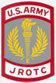 PSD ARMY JROTC CLASS SYLLABUS SY 24-25 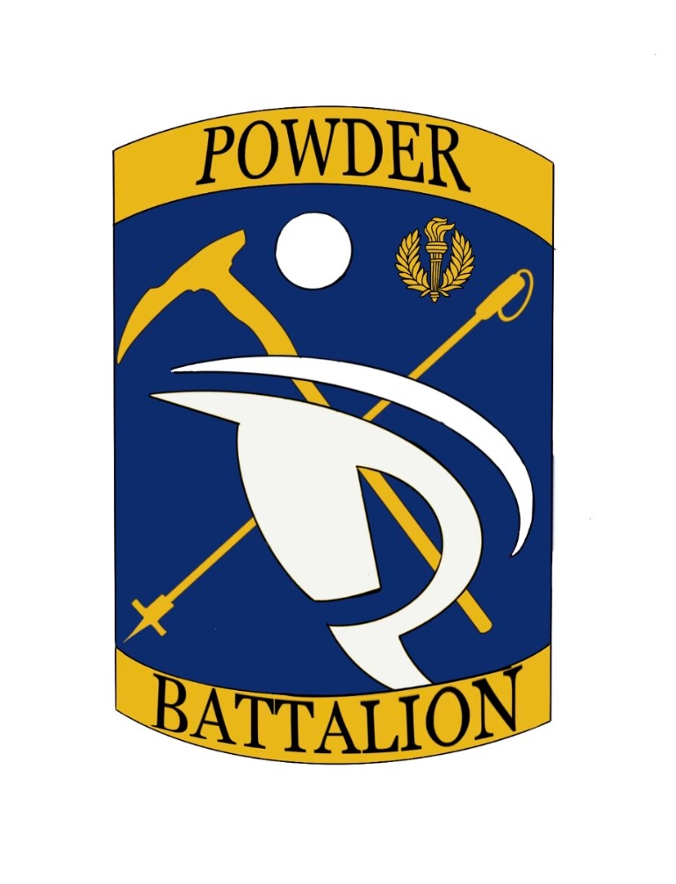

1. INSTRUCTORS’ NAMES: Captain (R) Roy L. Roby Phone: 970-488-6164
Room Number: 218 Email: rrobyiii@psdschools.org

Sergeant First Class (R) Joel Kruschke Phone: 970-488-6200
Room Number: 218 Email: jkruschke@psdschools.org

2. COURSE AND TITLE: JROTC Leadership, Education, and Training (LET) Units 1-5.

3. INSTRUCTORS’ Available Hours: Monday - Friday 8:00a.m. - 3: 30p.m

4. TEXTS: Textbooks and LET Workbooks will be provided to cadets at no cost. All required reading material and workbooks will be available on the students’ computers. Students will be using the Cadet Portfolio to complete assignments.

5. COURSE DESCRIPTION: Welcome to the Poudre School District Junior Reserve Officers’ Training Corps (JROTC) program! The PSD JROTC Department is positioned to support your child’s desire to participate in this multi-dimensional program during the 2024-2025 academic school year. This course is designed to teach high school students the value of citizenship, leadership, service to the community, personal responsibility, and a sense of accomplishment, while instilling in them self-esteem, teamwork, and self-discipline. We anticipate a challenging and satisfying year for all our cadets and welcome your family to the POWDER BATTALION.

Enrollment in this high School’s Army JROTC Program is a beneficial step towards your child’s future. Our mission statement reflects the overall meaning and purpose of JROTC, which is “To Motivate Young People to be Better Citizens” by preparing high school students for responsible leadership roles while making them aware of their rights, responsibilities, and privileges as American citizens. Your child will embark on one of the most interesting and complimentary educational experiences of their young developmental years. JROTC Cadets will have many opportunities to embrace and enhance learning citizenship attributes that will support lifetime endeavors. WE DO NOT RECRUIT! We can provide information if a student is interested in the U.S. Army or any branch of service. Our objective is that all students graduate from high school on time, and that they have a foundation of skills, which will enable them to be successful citizens after graduation.

6. PREREQUISITES: JROTC is offered as a 4-year program with a varied curriculum offered throughout each year that will progressively challenge advanced cadets. The high school JROTC Program places no obligation upon the student whatsoever for military science and students are not obligated to complete a required number of semesters or years in the program. Following is a breakdown of the Leadership, Education and Training (LET) levels:

- LET 1: All freshmen and first-year JROTC cadets regardless of academic grade level. Credits Awarded: Social Studies, Health/Wellness, or an Elective credit.
Total Credits: 15 credits applied as necessary by the Counseling Department.

- LET 2: Second-year JROTC cadets who have completed LET 1 and are at least sophomores. Credits Awarded: Civics/Gov, World Lang/Cultural, Health/Wellness, or Elective credit.
Total Credits: 15 credits applied as necessary by the Counseling Department.

- LET 3: Third-year JROTC cadets who have completed LET1 and LET 2 and are at least juniors. Elective credit, Personal Finance/Financial Literacy or substitute Elective credit.
Total Credits: 15 credits

- LET 4 (A & B): Fourth-year JROTC cadets who have completed LET 1, LET 2 and LET 3 and are seniors. Elective credit or Honor’s
Total Credits: 5 credits (Honor) 10 credits (Electives)

7. LEARNING OUTCOMES:

- Develop Leadership skills and learn how to implement them in society to manage people.

b. Appreciate the ethical values that support good citizenship.

c. Build effective relationships with peers, co-workers, and the community.

d. Think logically and communicate effectively (Speaking and Writing)

e. Incorporate principles of mental and physical wellness into behaviors and decisions

f. Maximize potential for success through learning and self-management.

g. Relate events in U.S history to choices and responsibilities Americans have today.

h. Characterize the role of the military and other national service organizations in building a democracy and maintaining peace in a democratic society.

8. DEVELOP CORE ABILITIES:

- Build your capacity for life-long learning.

b. Communicate using verbal, non-verbal, visual, and written techniques.

c. Take responsibility for your actions and choices.

d. Do your share as a good citizen in your school, community, country, and the world.

e. Treat self and other with respect.

f. Apply critical thinking techniques.

9. INSTRUCTIONAL APPROACH:

- The JROTC program is cadet-centered and offers many instructional techniques designed to
teach, challenge, and develop leader and teamwork skills through academic and co-curricular activities. Classes are taught through a combination of lecture, hands-on/performance-oriented tasks, group work, practical exercises, demonstrations and drill. Cadets will often be required to teach classes, lead group work, and be responsible for organizing and leading co-curricular activities.

b. Cadets will participate in physical training (PT) one day each week (this year it will be conducted on Fridays) and be evaluated for both their effort and accomplishments. Typical activities will include physical conditioning drills and team sports. More details will be provided about our PT program in class.

c. The JROTC cadet uniforms and components worn by the student will be issued to them at no cost. Cadets will sign for the uniform and pay for lost or damaged uniform items. All cadets are required to wear their Army uniforms one day each week (this year uniforms will be worn on Wednesdays) and at other times as designated by the Army Instructors. Cadets will receive a new or dry-cleaned uniform. Upon leaving the JROTC program the student is responsible to return a clean uniform. ASU Jackets/Trousers are dry cleaned only and OCP uniform may be machine washed with no bleach. Wednesdays will also be designated as Leadership Lab (LL) days where cadet leaders will primarily be responsible for the conduct of classes. Typical Leadership Lab Day activities will include instruction in drill and ceremony, uniform inspections, presentation of awards and promotions, assessments, and other activities specific to the day when all cadets are in uniform. Uniform inspections are graded events. Uniform deficiencies are documented on a checklist. If a student misses uniform day they will wear the uniform the first day back to class.

10. BENEFITS:

a. The JROTC Program provides the school system with another development feature, which presents excellent training opportunities in citizenship, administration, management, supervision, leadership, and responsibility. JROTC also provides the opportunity for the exercise of authority and respect for school rules and law and order.

b. The student can rise competitively through the Corp of Cadets organization from the rank of Cadet Private to Cadet Colonel, from the position of squad member to Battalion Commander based on their performance and ability. Should a student want to pursue the military services he or she may be entitled to an advanced promotion upon entering that service, depending on the number of years completed in the JROTC Program.

11. INTEGRATED CURRICULAR ACTIVITIES:
The student will have the opportunity to participate in some or all the following integrated curricular and co-curricular activities. JROTC Program gives cadets the opportunities to participate in numerous before/after school and weekend activities. Cadets must have parental/guardian and SAI/AI permission to participate in the following integrated curricular activities:

- Drill Team Competitions (armed and unarmed)
- Color Guard
- Honor Guard
- RAIDER Team
- JROTC Cadet Leadership Challenge (JCLC) - Summer Camp
- Archery
- Air Rifle Competitions JROTC Leadership and Academic Bowl (JLAB)
- Robotics (Drones) Competitions
- Annual Military Ball
- Annual JROTC Awards Ceremony
- Annual Command Inspection (mandatory attendance)
- School and community service activities

12. SPECIAL CLASS REQUIREMENTS:

a. All students must participate in the Annual Command inspection and attend rehearsals.

b. If a student volunteers for the drill team, color guard, raider/rifle/archery team, he/she must attend practice sessions. Team sports will travel and compete throughout the United States.

c. Mandatory formations and meetings: There will be a daily mandatory formation prior to class. Battalion Staff will conduct Command and Staff meetings and planning meetings prior to any event or activity. Battalion Staff will be evaluated for advancements and positions by the SAI/AI.

d. All cadets are required to read the weekly training schedules and posted short/long range calendars. Scheduled training, locations, uniform wear, and other items of information are noted in the schedule. Cadets are responsible to comply with the schedule.

13. EXPECTATIONS AND CLASSROOM RULES:

a. Each cadet will be issued a copy of the Cadet Creed, Leadership duties and Responsibilities Chart, and a Promotion Rubric. These references outline in detail expectations for cadet conduct, discipline, rules, and policies of the JROTC program. Cadets are expected to adhere to all school and district policies. JROTC is about good citizenship on or off campus, and cadets will be held to a higher standard than many of their peers.

b. Cadets should be prepared for class and follow the classroom rules (posted on the front board). This includes having the proper tools (computers, text, paper, pencil/pen, etc.) seated and ready to begin when the bell rings. Cadet Leaders (Cadet NCOs and Cadet Officers) must be prepared to enforce classroom rules as part of their duties.

c. Motivation and effort is important to a cadet’s success in JROTC. Cadets may receive high grades in the class even if they do not necessarily receive the highest grades on evaluated areas. There are many opportunities to step forward and “walk your talk.” The Army Instructors and cadet leaders are always looking for those cadets who are willing and able to take charge and get the job done.

d. Classroom participation is important and cadets are highly encouraged to become involved
in JROTC teams and other co-curricular activities. Cadets who merely attend class – even those who consistently receive superior grades for their academic work – yet fail to participate in our co-curricular activities are not taking full advantage of what the JROTC program has to offer.

- Cadets are expected to give their best effort in all their classes, not just JROTC. Cadets who
fail to achieve and maintain a minimum cumulative grade point average (GPA) of 2.0 (“C” average) will not be allowed to hold leadership positions (and may be demoted), be a member of a JROTC team or participate in other JROTC co-curricular activities or field trips.

- Cadets should return all required forms with complete information to the Army Instructors on
time. Cadets will not be allowed to participate in many activities or be issued a uniform until the required forms with parental/guardian signatures and other information are returned to the Army Instructors. Field trips and team events require traveling (fly/drive) at times and will need the school district forms filled out completely and the military forms needed to be approved for funding.

- There will be no eating or drinking in class (except water). Exceptions to this policy is when
meetings are conducted in our classroom at lunchtime and for special occasions.

i. Cell phones and other personal electronic devices, such as gaming consoles, will not be used in class, except as designated by an instructor. Cadets will turn phones to vibrate in the classroom. The first failure to comply will result in an Army Instructor safeguarding the device in the Instructor Office for the remainder of class. Repeated instances of non-compliance will result in PSD Administrator safeguarding the device until a parent or guardian picks up the device.

j. Cadets needing automation support for completing required leadership duties will use computers in the staff area. If a student is unprepared for class, the instructors may let a student borrow a computer for class that day. Cadets will not use the extra classroom computers unless authorized by an instructor.

k. Cadets will not enter either the Army Instructors’ Office or Supply Room without the permission of an
Army Instructor or Cadet that was placed in charge by the SAI/AI.

l. Common courtesy to other cadets and the Army Instructors is always the order of the day. Always be professional and treat others like you would want to be treated.

14. CLASSWORK:

a. Most of the academic work will be completed in class. However, homework will sometimes be assigned, especially when group work assignments or activity planning is involved. Failure to turn-in completed work on time will result in a point reduction.

- A cadet’s academic success in JROTC is important to the Army Instructors. Feel free to contact an
Instructor with questions or for a clarification of assigned work. Do this BEFORE an assignment is due because it will not be an acceptable excuse on the day that work is due!

- Cadets missing an assignment or test because of an excused absence will have equal
number of days of the excused absence to make-up the work or test. Cadets missing an assignment or test because of an unexcused absence will not be allowed to make-up the missing assignment or test and will forfeit the applicable academic points. It is your responsibility to learn what work you have missed and make it up within the prescribed time limits!

d. Be prepared and participate! Being prepared includes bringing an adequately charged computer to class. Cadets should ask questions - and be prepared to answer questions - about the day’s work. Subjects, assignments, references, and activities will be posted on the Monthly Study Assignment Calendar. Cadets should read the calendar frequently, take notes about assignments that are due, and ask questions if clarification is needed. RED ENTRIES ON THE ASSIGNMENT CALENDAR INDICATE GRADED ASSIGNMENTS!

15. GRADING SYSTEM:

a. Cadets are graded in three general areas: Participation, Uniform, Assignments. Cadets will have 48 hours to make up any assignments if their absence is excused.

b. Uniform Day is Wednesday! Cadets will get credit for wearing the uniform for that day (all day). If a cadet has an excused absence, they must wear the uniform the next day they return.

c. Assignments, such as the Veteran’s Day Parade JPA, Regimental Inspections are mandatory events. If there is a conflict, arrangements must be made prior to the event. the parent must send an email to the instructors and cadets must arrange an alternate assignment prior to that event.

- Participation is scored by individual instructors and will include cadet’s attitudes toward student leadership.

- Weekly Grades: Cadets will start each academic week with 100 points and lose points for poor attendance (up to 10 points; 2 points for each unexcused absence or tardy), poor or lack of participation (up to 20 points; 4 points per day), and not completing all required assignments/quizzes/projects by the due date (late turn in will be dealt with on a case by case basis; make up plan discussion must be initiated by the student with their instructor)

- Weekly Attendance: Being present and being on-time are keys to success in life. They are almost 10% of your JROTC grade (10 points/week). Cadets that are tardy or absent without a valid excuse will lose 2 points respectively per session (5 sessions per week). Excused absence or tardiness will not result in a loss of points.

- Weekly Participation: Almost every activity in life requires teamwork and active participation (this is especially important in mission-oriented endeavors such as public safety, military, firefighting, etc.). To succeed as a member of a team, you must treat yourself and others with respect. Failure to participate in group activities or disrespectful behavior will result in loss of points. Cadets start each week with 20 points and can lose points for poor participation. For example: repeatedly- using phones without permission; disrupting class learning; being unresponsive in class; disrespecting other cadets; cursing in class; etc. If a student’s behavior has been addressed with the instructor many times without improvement, then the instructor shall decide to bring in other parties (parents, dean, social worker, etc.) to see what other interventions can be used.

- Assignments and Exams. Cadets will complete several assignments, quizzes, project(s), and proficiency exams that will be averaged for a total of 70% of final grade.

- Uniform issue and Inspections. Cadets will be issued uniforms. What type of uniform issued will depend on the level/status of the cadet (your instructor will go over this in more detail). Cadets will be required to attend uniform inspections once the instructors have finished issuing operations. Cadets can expect this to start around the 1st or 2nd week of October.

- Required Paperwork: Cadet Command requires certain documents to be maintained as part of each cadet record. Required Paperwork will be given out at the beginning of class with a parental permission/syllabus for legal guardians. When all paperwork is returned, cadets will be awarded credit for these items just like other assignments. THESE ARE THE FIRST GRADED ASSIGNMENTS!

- Physical Fitness Participation: Each Cadet is expected to fully participate in physical fitness events as part of JROTC curriculum (when these activities are allowed by the school leadership and if the student does not have a medical reason for not participating). Physical fitness events shall include drill and ceremonies, the cadet challenge events, and organized athletics that build teamwork. Cadets that have physical limitations must provide medical documentation from a medical health professional, school nurse, or authorized school leadership to be exempt from participation. Students' participation will not be graded on their athleticism in any activity.

Category | Percentage of Weekly Grade
Weekly Attendance (10 points per week) | 10%
Participation (20 points per week) | 20%
Assignments/Exams including Portfolio; Required Paperwork (Privacy Act Statement/Uniform Receipt/Syllabus); (70 points per week) | 70%
Total | 100%

15. ADDITIONAL INFORMATION FOR CADET AND PARENTS:

a. Cadets in the JROTC Program are expected to comply with directives given by the student chain of command. Failure to comply will result in demerits, discipline referral, and/or lowering of performance grade. No cadet will use position or grade in a manner that benefits them only, unethical, or considered by SAI/AI not in good taste of the organization.

- If a cadet encounters difficulty in JROTC lessons or other school courses do not be afraid to seek help from the SAI/AI. Instructors are available to confer with parents and gladly to do parent/teachers conferences throughout the year. Due to class schedules instructors may not be able to get to the phone immediately. Parents may also use our email addresses to express concerns or set up meetings.

- All cadets will earn cadet rank through performance in class, academic grades, uniform wear and personal appearances and overall conduct. Cadets should set a professional example in appearance, discipline standards, treatment of peers/subordinates or school students not in the program.

16. Parental or Legal Guardians:

__________________ My cadet/student does not have any medical conditions or physical limitations currently.

__________________ My cadet/student has a medical condition or physical limitation that may interfere with PE class.

PLEASE EXPLAIN or Contact SAI/AI: (Remember to think about HIPPA)

PARENTAL SIGNATURE _________________________________________DATE: __________________

I have read the attached outline and understand the policies, expectations, and requirements of the course in which I completely understand.

STUDENT SIGNATURE ___________________________________________ DATE: ___________________

STUDENT’S PRINTED NAME ________________________________________________________________

I have read the attached outline and understand the policies, expectations, and requirements of the course for my student/cadet.

PARENT SIGNATURE _____________________________________________ DATE: ___________________

PARENT’S PRINTED NAME _________________________________________________________________

