Poudre School District
Five Year Comprehensive Grant
2020-2025
Community Assessment

An assessment of the current state of Poudre School District’s Early Childhood Education program in Poudre School District (PSD) and Larimer County
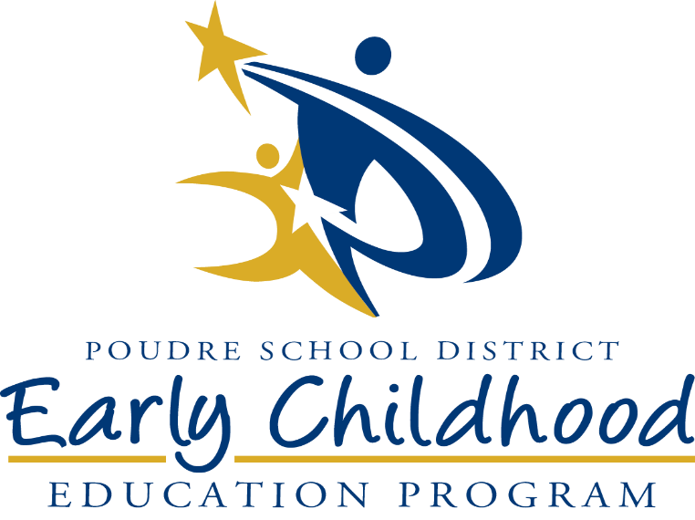

Prepared by the Poudre School District Early Childhood Education Program in Partnership with District and Program Staff, Families, and Community Partners

Table of Contents

- Executive Summary of the Community Assessment ………………………….…..3
  - Overview
  - Summary of Process
  - Major Findings and Recommendations
- Overview of the State of the Grantee………………………………………………8
  - Grantee Information
  - Notable Area for Growth Changes
  - Demographics and Program Information
  - Service and Recruitment Areas
- Methodology – Community Assessment Process…………………………………21
  - CA Process
  - Sources of CA Information
  - Methods of Data Collection
  - Methods of Data Analysis
- Data Collected and Findings ……………………………………………………..26
  - Information and Demographics of Families Served
  - Strengths and Needs of Families Served
  - Access and Availability of Community Resources
  - Collaborative Arrangements, Partnerships, and Formal Agreements
  - Sustainability and Financial Implications
- Data Review and Analysis………………………………………………………...39
  - Major Issues, Trends or Concerns
- Recommendations and Priorities…………………………………………………..45
- References………………………………………………………………………….48
- Acknowledgements…………………………………………………………………50
Executive Summary of the Community Assessment
Overview
The Poudre School District’s Early Childhood Education (PSD ECE) community assessment finds that within the geographic boundaries of Poudre School District’s Comprehensive grants, including Early Head Start and Head Start, the services provided to families with young children are necessary for students to thrive. These services meet many, but not all, the needs of families with young children.
Families strongly embrace their role as the first and most enduring educator in their child’s life. They seek a strong social-emotional foundation for their children from the earliest ages, to produce children who are resilient and skilled at navigating change and challenges. Families are aware of the needs that the pressures in the community produce and give the program strong and consistent recommendations for next steps that PSD ECE must take to meet their needs. (Trust for Learning, 2019)
The PSD ECE program is ready to act on the recommendations of our community assessment. Using ongoing progress monitoring and 5-Year Grant goals set for the first time in the 2015-2020 submission, the program shows evidence of goal progress and program quality in ongoing monitoring areas like Finance, Student Achievement, Attendance, and Transitions. PSD ECE has fully-utilized the logic models provided by the Office of Head Start to annually assess the community, engage in ongoing monitoring and self-assessment, update our goals and measurable objectives, improve budgets, and provide trainings and program services to improve program quality. The program is also aware of and able to take next steps on areas that remain challenges. Evidence and formative processes help PSD ECE understand the current state of program quality and what needed actions can help achieve next levels of excellence. The program is proud of formative and summative assessment processes that are helping to ensure that every enrolled child and family will be ready for Kindergarten.
Summary of Process
The PSD ECE program followed all federal guidance for the community assessment. Because of close adherence to program planning cycle and ongoing progress monitoring requirements throughout the current 5-year grant, the program is ready to implement a robust community assessment process. PSD ECE is ready to take next steps to meet the needs of the community as expressed during the community assessment.
PSD ECE used district, county, and local data sources, including the expertise of Region VIII Training and Technical Assistance assets and the PSD ECE Leadership Team members, whose daily work embeds them with families, community partners, and evidence of the PSD ECE program’s impacts. PSD ECE leadership team members partnered with key community assets to design and implement the Community Assessment Forums and Surveys, which convened district and early childhood staff members, county and district community partners, and early childhood and community family members. Results from all sources were compiled and categorized by a three-member team that prioritized the contributions of the forums and surveys. The team sorted all the recommendations received the in categories described below. The results have been reviewed and edited by all PSD ECE leadership team members, Policy Council Executive Committee, and finally approved as a document by Policy Council and the PSD Board of Education. Results have been widely shared with staff and community members, and PSD ECE is energized by the findings. The reader will find items in more than one area below because PSD ECE is ready to use advocacy, awareness, immediate and continued action, 5-year grant cycle action, and long-term action to ensure the program will see each of these recommendations through to resolution.
Major Findings and Recommendations
Advocacy and Awareness:
Some of the far-reaching and fundamental recommendations and actions suggested are not within the sole realm of control for PSD ECE. These ideas include organizations with whom PSD ECE partners and decisions that are not made solely by the program. Advocacy and awareness recommendations require the program to advocate for changes to regulations or funding, or to deepen understanding of the impacts of service gaps in county, city, and district partnerships. Short of achieving full resolution of those gaps through far-reaching changes, advocacy and awareness items require that we devise meaningful action alone as well as in partnership with other community assets to work around gaps.
Advocacy and awareness recommendations urge PSD ECE to pursue more: more slots, more funding, more types of funding, longer days, more days each week and year.
- Pursue more tuition-based slots.
- Advocate for an accurate funding basis for students with identified needs served but not funded based on count date.
- Seek more no-cost full-day slots that are federally funded.
- Increase no-cost state-funded slots that provide access for families for full-day programming.
- Seek more tuition-based slots for families who don’t qualify for no-cost ECE to address the gap. Perhaps offer a sliding scale.
- Seek opportunities for full-day, full-week programming
- Seek opportunities for wrap-around care

Advocacy and awareness recommendations were also made regarding staffing and salaries.
- Successfully hire and retain staff members with skills valued by the ECE community such as the ability to work with diverse populations, cultures, and languages.
- Pursue other funding models to keep up with salary/cost of living increases.
- Maintain comparable wages for highly qualified staff.
Immediate or continued action:
Short-term or continued action recommendations can or will be implemented immediately because they are of the highest level of need or easily achievable for immediate results.
- Continue work on integrations between ECE elementary systems through professional development, collaboration, partnerships, and community assessment.
- Marketing and recruitment to reach families who need our program in a variety of languages and communication models.
- Use social media, text messaging, and emailing to better align with the times.
- Successfully hire and retain staff members with skills valued by the ECE community such as the ability to work with diverse populations, cultures, and languages.
- Offer family education and other services using service models that provide equitable access by all children and families.
- Pursue space in neighborhood schools and quality community partnerships.
- Increase the use of district transportation to help get kids to school.
Within the next 5-year grant cycle actions:
These recommendations require time to develop and strategically plan for achievement. These are initiatives that solve complex problems and take time to implement, monitor, and adjust.
- Wellington Learning System – Board of Education (BOE) approved strategy to provide ECE services in this geographically isolated area of high growth and poverty to ensure children are PK- and K-ready.
- Title Schools Project – BOE approved use of mill/bonds surplus to build two ECE classrooms onto 5 of 6 Title One schools to ensure children are PK-and K-ready.
- Offer family education and other services using service models that provide equitable access by all children and families.
- Increase use of transportation to help get kids to school.

Long-term action:
Recommendations that fall under long-term action planning are important ideas for us to hold and develop over time.
- Wellington Learning System – BOE approved strategy to provide ECE services in this geographically isolated area of high growth and poverty to ensure children are PK- and K-ready.
- Title Schools Project – BOE approved use of mill/bonds surplus to build two ECE classrooms onto 5 of 6 Title One schools to ensure children are PK-and K-ready.
- Publicize information about early intervention services
- Offer family education and other services using service models that provide equitable access by all children and families.
- Direct, integrated communication with district, families and partners.

Overview of the State of the Grantee
Grantee Information
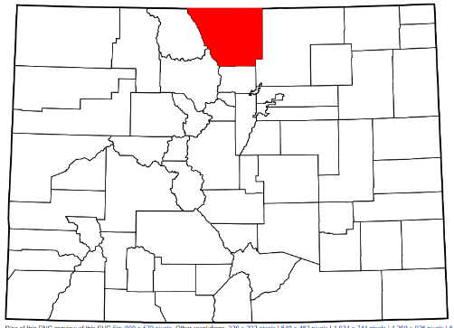
Poudre School District is in Larimer County, north of Denver and South of the Wyoming/Colorado border. Service areas for Head Start preschool include those boundaries within the catchment area of Poudre School District (PSD). PSD, the 9th largest school district in Colorado, includes 50 schools, covering 1,856 square miles in northern Colorado, including Fort Collins, Laporte, Timnath, Wellington, Red Feather, Livermore, Stove Prairie, and parts of Windsor. (Poudre School District, 2018) Last year, Poudre School District was one of 16 school districts in the state that had student growth of more than 101 students. (Colorado Department of Education, 2019) For Early Head Start, PSD ECE serves families in Larimer County, covering 2596 square miles in Northern Colorado include PSD boundaries, as well as Loveland and Estes Park. Larimer is the sixth largest county in Colorado.
Fort Collins and Larimer County both have growing populations, with 17% and 15.9% respective growth increases since 2010. The average household size in both the county and the city is 2.48 people/household, which is slightly smaller than the national average of 2.63. In the county, people under the age of 5 make up 5.2% of the total population and for Fort Collins, they make up 5.4% of the total population. (United States Census Bureau-Quick Facts Fort Collins city, Colorado, 2018)
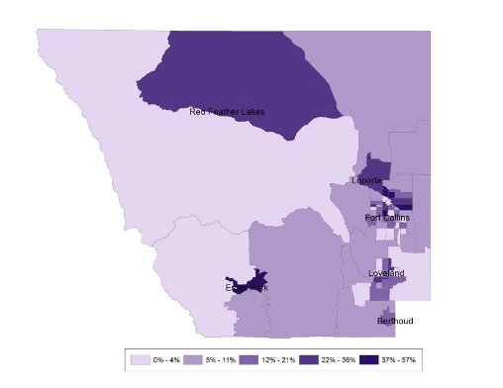
A Kids Count Colorado 2019 map outlining rates of child poverty in Larimer county is shown below. The major economic and sustainability finding of the Community Assessment is that self-sufficiency is difficult for families to achive in the county and PSD catchment area because of low income rates and a very high cost of living.
Wellington Area
Child Poverty Rate Map of Larimer County, CO
Notable Areas of Growth Changes in the Community
Two notable areas of growth for the service and recruitment area are in Wellington and Timnath. Each is a small town in the catchment area that is growing and expanding with new construction. Wellington is located to the northeast, and Timnath to the southeast, of Fort Collins. To respond to population growth in both towns, PSD ECE has sought partnerships and expansions that will meet the increased student needs. Of these two, the more urgent need/focus has been in Wellington because poverty has a greater impact in this geographically larger and more isolated area. Wellington is not accessible through public transportation to Fort Collins, and its catchment area extends from the I-25 corridor to the east to the Wyoming border to the north (red oval).
Timnath Area
PSD continues to partner with a community partners to offer additional preschool slots in Wellington. PSD ECE added a classroom in Eyestone Elementary School in 19-20. In September 2019, the PSD Board of Education approved plans to design a Prenatal-High School Graduation program in Wellington that will be called the Wellington Learning System. This system will be designed in partnership with the Wellington community over the course of the next two years and be operational in the fall of 2022. The purpose of the program will be to ensure that children acquire language and literacy skills and enter preschool or Kindergarten without developmental or academic gaps.
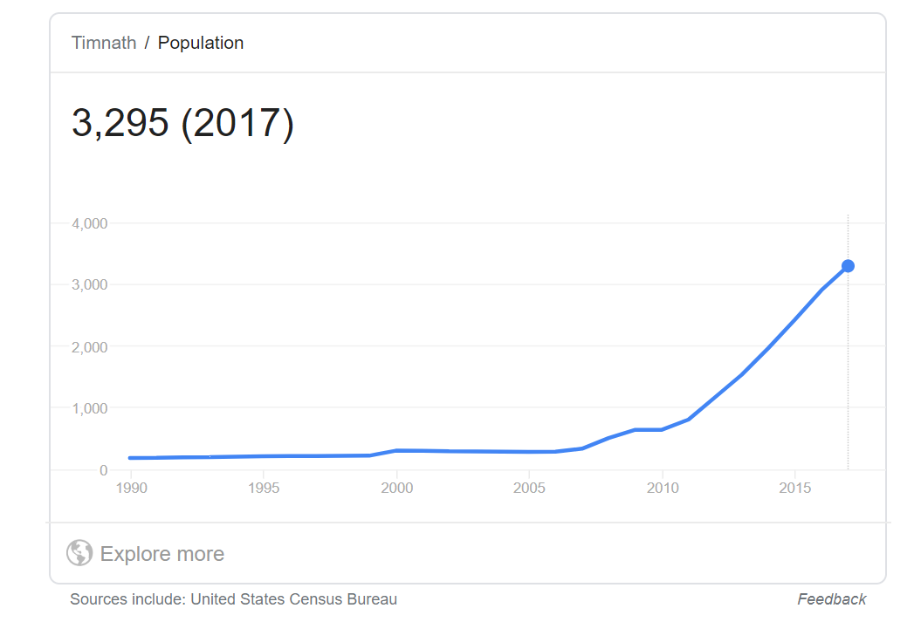
While the population in Timnath is growing, the demographics show a population with more ability to access transportation and seek services nearby in Fort Collins. In the area southeast where the Timnath catchment is located (blue oval), PSD is building two early childhood classrooms inside the new elementary school scheduled to open fall of 2021.
Other notable areas of the community poverty map lie north of Fort Collins, in the Red Feather Lakes area. The population density in this mountainous area is far less than Fort Collins. Additionally, despite their need, many families opt out of early care and education supports in these areas, which is why the partnership with Basecamp offers an array of services that meet the needs of families at the Red Feather Lakes and Stove Prairie elementary schools. PSD ECE funding provides CPP slots, and Basecamp interviews families to provide other care and education services for families to opt into in order to meet their needs.
For Early Head Start, PSD ECE serves families in Larimer County, covering 2596 square miles in Northern Colorado that include PSD boundaries, as well as Loveland and Estes Park. Larimer County has a population density of 115.4 people per square mile. In contrast, Fort Collins, has a population density of 2652.8 people per square mile. This effectively creates a gap in EHS services across the county, because program enrollment of 108 is filled rapidly in the most densely populated areas of the county: Fort Collins and Loveland.
Demographics and Program Information
The racial makeup of Larimer County, Fort Collins, Poudre School District, and the PSD ECE program is shown below. There have been only slight fluctuations in this overall makeup in the past 10 years.

(United States Census Bureau, 2018) (Colorado Children's Campaign, 2018) (Poudre School District, 2019)

The county engages in a process much like that of PSD ECE’s goal-setting and ongoing monitoring. The county’s current goals are, 1) Larimer County works collaboratively to ensure adequate public infrastructure is available to support the needs of our growing community; 2) Everyone in Larimer County has access to economic opportunities and a vibrant quality of life. We work together to remove barriers; and 3) Larimer County government is ready to support the future service needs of our residents and visitors. In goal two, one of the main strategies is “By 2023 . . . to work collaboratively with private and public entities to increase capacity for child care so that at least one licensed child care spot in family child care homes, child care centers, or preschool settings exists for every 1.5 children in the community.” While county work and linkages to collaborative partnerships is strong and well-managed, state funding formulas limit allocations to counties as well as school districts. The local community has a long history of voting in supplemental tax increases to secure needed services, such as the estimated $12M secured for county-wide increased mental health services in 2018. These services will include increased funding in all three Larimer school districts, and explicitly include increased services to young children and families. However, with base funding strained, and initiatives brought before voters filling the gaps, the continuity of county services such as transportation, housing, health, and childcare are all strained. One of the considerable responsibilities of the PSD ECE program in this community milieu is to advocate for change and to devise, collaborate, and secure increased funding for programming that assists in filling the gaps.
The mission of Poudre School District is, “Educate . . . Every Child, Every Day.” According to 2018 Poudre School District Data, in 52 neighborhood and charter schools the district educates more than 30,000 Kindergarten through 12th grade students each year. Among those students, 30.6% qualify for free and reduced lunch, 7.41% have been identified with special needs, 13.17% are identified in Gifted and Talented programs, and 7.26% are identified as English language learners. (Poudre School District, 2018)
School system performance as rated by the Colorado Department of Education (CDE) District Performance Framework system is strong. For 2019, the district received an Accredited rating. All the elementary and middle schools, and many of the high schools are rated at “Performance” level on their School Improvement Plans. This is the highest-rated level for Colorado schools and means that they are meeting the needs of 53-100% of enrolled students when key performance indicators are rated in both student achievement and student growth. The district and school Improvement Planning process functions very much as the Self-Assessment and Ongoing monitoring process does for the PSD ECE program. This significant area of overlapping focus on student outcomes is one of the major sources of strength in aligning the PSD ECE program with district K-12th grade initiatives.
Within this positive picture of student growth and achievement, there are students for whom outcomes lag. The CDE Performance Framework disaggregates the results of English Learners, Free/Reduced Lunch Eligible Students, Minority Students, and Students with Disabilities from the results of all students. This data shows that these subgroups do not perform at the same level in either achievement or growth as all students in both state and PSD data sets. PSD subgroups outperform state averages often, but not always, and the district and school improvement plans center around moving achievement and growth up for these students. As a result of close ongoing monitoring of student demographic data plotted against academic growth and achievement by PSD’s Department of Research and Evaluation and schools, PSD ECE now knows that the key indicator for lower academic growth and achievement outcomes is lower income. Across all disaggregated groups, the performance of individuals for whom low income is not a barrier parallels the performance of all students. This is a critical finding in a community in which the self-sufficiency standard remains out of reach for so many families because of the very high cost of living in Fort Collins and Larimer County.
Program Information
“The Poudre School District Early Childhood Education Program exists for our community’s most vulnerable children and families. We ensure that our enrolled children are ready for and will be successful in Kindergarten,” is the mission. PSD ECE’s vision is “To empower our community’s eligible children and families to build a foundation for learning, as measured by their readiness for Kindergarten and beyond.”
The PSD ECE program served 1,138 students in 2018-2019, with marked differences from the district in overall enrolled populations that are explained by our sources of funding for services. In the ECE program, 53.6% qualify for free/reduced lunch, 35.14% have been identified with special needs with an IEP or IFSP, and 27% are identified as English language learners or Dual language learners. As a result, each year the PSD ECE program transitions the most vulnerable 25% of the incoming kindergarten class into the district instructional K-5 program. The distinctions in enrolled populations are explained by an analysis of blended funding sources, which include Head Start, Colorado Preschool Program, Early Childhood Special Education, and Tuition-Based. Of these funded sources, Early Head start serves 108 children and families in 92 Home-Based and 16 Center-Based slots; Head Start serves 275 preschool slots; the Colorado Preschool Program serves 453 preschool slots; tuition-based serves 56 slots. For 2018-19, the total number of Head Start children served is 308, and the total number of Early Head Start children and pregnant women served is 147. Annually, PSD ECE receives funding for approximately 200 early childhood special education preschool slots, typically assigning more than 50 to HS funded slots. However, the remaining 100 students with identified needs are served by the program unfunded through use of reserves. (Poudre School District, 2019)
PSD ECE’s goals and measurable objectives for the past 5 years have held the program accountable for kindergarten readiness. PSD ECE has become aligned with the district by focusing on formative processes to ensure that the academic and behavioral needs of children are assessed, that instruction and interventions are differentiated for each student, and that the outcomes of instruction and intervention are re-assessed. Overall outcomes in the 6 domains measured by TS GOLD for students are seen in the graphs below. As measured by TS GOLD, aggrregate results show that most students are succeeding, which mirrors the results achieved across the district. PSD ECE results are obtained across a population with higher proportions of students with much greater academic need.
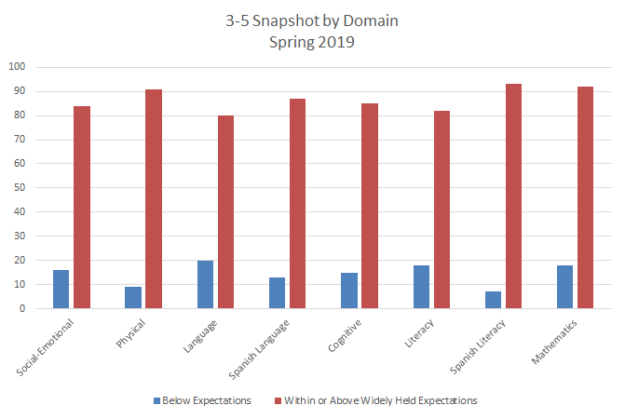
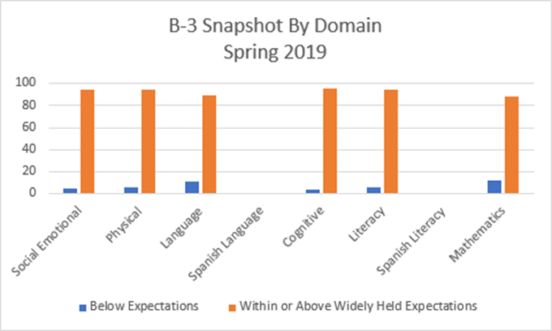

Looking at sub-populations, ECE children who are learning English in addition to other languages, those with IFSPs and IEPs, those who are racially or culturally different, and those with higher asset scores (indicating higher risk factors) score at achievement and/or growth levels that are lower than typical ECE children. There is a clear evidence-based need to ensure that formative processes, like home visit and classroom instruction differentiation based on prior assessment, is well-used to meet the needs of individual children and families. To ensure that the program monitors strong use of formative processes, the monthly Policy Council data reporting in the area of student achievement is shown on the next page.
A highlight of this community assessment is that the formative approach underlies PSD ECE’s work in every grant goal area, and is an important linkage to district priorities and initiatives. For example, the Attendance Impact Team and the Studente Achievement Outcomes Team model their work on Leading High Impact Teams, by Paul J. Bloomberg and Barbara Pitchford. Dr. Pitchford was a consultant to the district’s Title One schools two years ago, and the PSD ECE leadership team attended the school meetings she facilitated. The formative approaches Dr. Pitchford taught are responsible for the high level of elementary school ratings reported in the district outcomes area above. She also influenced PSD ECE’s approach to change and growth.
Goal 1: Student Achievement Children will show appropriate readiness at each developmental milestone leading to school readiness from Prenatal until they enter Kindergarten. |  | Analysis: Is preliminary levels inputting regular for all children?  Do the home visiting and classroom curricula help staff members collect quality documentation to meet the preliminary levels-setting deadlines? Are instructional staff members prenatal-K transition gaining experience in formative processes?
Number of Preliminary Levels set for objectives 8a-b, 9a-b, 1a-b and 3b out of the total possible number of set levels. | EHS:  PK:
Percentage of high-quality documentation for Preliminary Levels is high based on evaluation by the quality rubric. | EHS:  PK:
Once per year goal: 4% increase (to 3.78) in Instructional Support domain of the Classroom Assessment Scoring System. (CLASS) | Report once in March of 2020 | What are we learning from this year’s CLASS data that is important to next year’s 5 Year Grant Application?

Working formatively has helped us the most to change into a learning organization as required by OHS with the first 5-year grant cycles. The methodology of defining our terms, taking action based on our understanding, assessing the outcomes of our actions using evidence, communicating and reflecting with stakeholder groups, and making course corrections or taking new, evidence-based actions has been very valuable. It has also helped us to show the district important commonalities in PSD ECE strategic planning and the district’s Unified and School Improvement Plans, which has led to unprecedented alignment in ECE and district initiatives. Expansion of PSD ECE to create more all-day classrooms, and the Wellington and Title I Learning Systems are examples of that alignment. These initiatives will be driven by community needs assessments and co-design of services with resulting increase in prenatal to 36-month service that ensure childrern no longer enter PK or K with gaps.
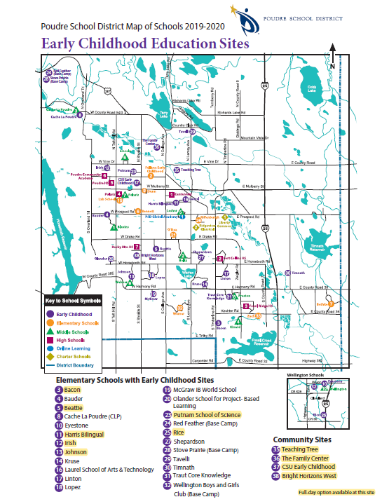
Service and Recruitment Area
PSD ECE classrooms are in 20 different elementary schools, and EHS center- and home-based services are in 4 partner center classrooms and 92 homes across the community. Services provided at 7 community partner sites help us address the community’s needs for early care and education in Early Head Start (EHS) and Colorado Preschool Program (CPP) classrooms.
School and partner center sites are carefully selected to ensure that distinct populations, such as Latinx in north Fort Collins, or the families located in the mountains, can access care and education that is tailored to their needs. In Estes Park, needs are being addressed in a close partnership with the Early Childhood Council of Larimer County (ECCLC) and the Estes Valley
Investment in Childhood Success (EVICS). Linkages to both ECCLC and EVICS are strong, as both EVICS and PSD ECE have Board seats at ECCLC.
Some PSD schools have more than one early childhood classroom, and some have stand-alone classrooms. For example, PSD ECE has classrooms at every Title One-funded elementary school to meet the greater needs in those neighborhoods. However, the program does not have classrooms in all elementary schools, based on need for services and space availability. Families are placed at their neighborhood schools whenever possible. Students attending neighborhood schools are more likely to have access to resources such as district and city transportation.
Transportation Within Service and Recruitment Areas
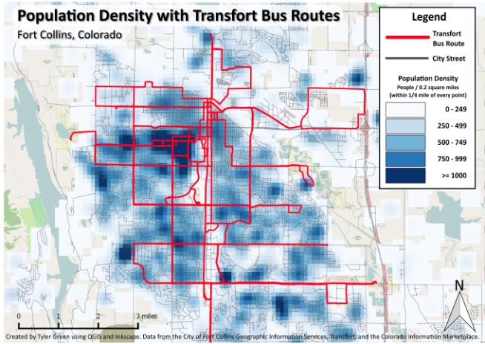
Transportation across the large and varied geographic region of the county, and even within the PSD catchment area, presents challenges. There is limited public transportation in Fort Collins which does not reach all areas in the PSD catchment area. Transfort, a regional public transportation service collaboratively funded by city, state, and federal sources, services Fort Collins based on densely populated areas, shown on the map above. The Flex bus line connects Fort Collins and Loveland, but other county and catchment areas are unsupported by public transportation. (Transfort, 2014) The Colorado Department of Transportation’s Bustang services areas throughout Colorado, connecting Fort Collins to Denver, but services few areas of Larimer county and costs are higher than those for Transfort. (Bustang, 2018) Families can use Transfort at a single ride cost of $1.25 and riders under the age of 18 can ride for free, with costs covered by the Bohemian Foundation. Barriers to access to city and regional transportation affect EHS and preschool families.
Within the PSD ECE program, transportation services provided to preschool children represent a significant source of non-federal share of the budget. Students who qualify for Head Start, an Individual Transportation Plan (ITP), and students who qualify for McKinney-Vento Services are routed through the school district’s regular bus routes. Other early childhood students may or may not receive transportation based on space available on existing routes. Transportation was reported during the community assessment as a barrier to preschool attendance, and PSD ECE’s progress monitoring of the attendance goal shows that access to district transportation increases preschool attendance. Transportation to full-day classrooms produces the best outcomes for preschool attendance. The lack of universal access to district transportation for all enrolled preschool families, and a need increase full-day classrooms with transportation are concerns the program will collaboratively address. The program will be seeking increased partnership with PSD Transportation and increased funding to support universal access.
Poudre School District Early Childhood Staff
PSD ECE’s program has 132 staff positions, including teachers, paraprofessionals, home visitors whose work is to ensure the Kindergarten readiness of each child. Managerial team members include enrollment, health, front office staff, managers and coordinators who respond to district and funder initiatives. The positions counted here do not include district departmental staffing. These departments support PSD ECE, but their positions are funded through the General Fund. (Poudre School District, 2019)
Seventy-one percent of PSD ECE staff members have a BA or MS/A/E degree in their field. Within the program, 92% of staff members are White, and 8% identify as American Indian, Asian, Black or African American, or are Multi-Racial. Of White staff members, 18% identify as Hispanic. Most staff members speak English as their first language and 8% of staff members speak a language other than English, primarily Spanish. Within the program, the largest language service groups in order are English, Spanish, and Arabic. Currently, the program employs a single full-time Arabic speaker. The program employs District and private Arabic and Spanish interpreters to support family meetings and trainings. The recommendation to increase the diversity and cultural skill of staff members is made by stakeholders during ongoing monitoring and self-assessment processes.

Methodology and Community Assessment Process
Community Assessment Process
The Head Start Performance Standards require the program, “To design a program that meets community needs and builds on strengths and resources, a program must conduct a community assessment at least once over a five-year grant period.” Office of Head Start grant processes mirror the activities of partners who also engage in mission-driven goal setting and evidence-based progress monitoring. To help the program with this important starting point for the 5-year grant submission, PSD ECE organized an inclusive group of stakeholders to advise the program. This includes Beverly Harris, a PSD ECE family member who has done work for Colorado Department of Education in the area of early childhood program quality. The planning phase of mapping and assigning work started at the ECE leadership team retreat in April 2019. In summer 2019, PSD ECE gathered data through review of the past grant period and ongoing monitoring, and national, local, and regional research. In August 2019, PSD ECE conducted the community assessment forums and surveys. After all the data were compiled, a three-person team comprised of a community member, the program director and the operations manager, analyzed and summarized the results in preparation for initial presentation to the ECE leadership team. The summarized trends, themes, and recommendations were shared at the September 19, 2019 Policy Council meeting, where families and community members had a final chance to provide inputs on the strengths and needs of the community. This Community Assessment document was written based on all the information and contributions and presented for review to the Early Childhood Leadership Team on September 27, 2019 and the Policy Council Executive Committee on October 7, 2019. The Community Assessment document was approved by Policy Council at the October 17, 2019 meeting and shared publicly via PSD’s ECE website immediately afterwards. Following the approval of the community assessment, PSD ECE conducted the self-assessment. Using the recommendations from self-assessment and community assessment, PSD ECE formed the 5-year goals and measurable objectives and developed all the remaining components required for this new 5-year grant submission including budgets, Training and Technical Assistance plans, the grant narrative, and the 5-year action plan.
Community assessment contributors included ECE and PSD staff members, community members, and families, including policy council members. The PSD board of education liaison participated in the community focus group as well as being an active board liaison to the Policy Council as required at every monthly meeting. Beverly Harris helped co-facilitate all community focus groups with the PSD ECE Operations Manager. The ECE leadership team (Director of Early Childhood Education; Assistant Director of Early Learning; Operations Manager; Quality Data Assurance Technician; Family and Community Engagement Coordinator; Eligibility, Recruitment, Selection, Enrollment and Attendance Coordinator; Disabilities Specialist; Finance and HR Technician; and PSD Health Coordinator), each contributed to the data and research portions as well as the survey or focus groups. Other employees who were critical to the work and feedback were the front office staff, who helped coordinate details for groups as well as the Parent Educator and Family Mentors (home visitors) who reached out to engage families to promote all voices in the process.
Sources of Community Assessment Information
The PSD ECE 5-year community assessment has many internal and external data sources. Please see the references page at the end of this community assessment for a complete list of sources. The program also collected quantitative and qualitative feedback from internal sources such as ongoing monitoring, survey results, community focus groups, and meetings for families, staff, and community members.
Methods of Data Collection
To collect external data, members of the leadership team divided the community assessment sections by area of expertise. PSD ECE used local, state, and federal data to gather the most current, reliable, and incisive data.
To collect internal data, the program used the results of the past 5 years of ongoing monitoring, surveys, and community focus group data. PSD ECE balanced our stakeholder group invitations to complete surveys and participate in the community forums to ensure results would include the viewpoints of families, ECE and non-ECE staff members, and community members. To contact families, PSD ECE emailed all current and past year families for whom the program had an email address. All communications were sent in English and Spanish, and an additional text message was sent in both languages to remind families to look for the email invite and survey link. For community members, PSD ECE used local government, Early Childhood Council of Larimer County, the ECE Health Advisory Board invite list, Social Services contacts, and local community partners who are Colorado Preschool Program contacts. For staff, PSD ECE sent out invites and surveys to all Poudre School District Staff as well as sending the survey through the weekly update targeting program and school staff where Early Childhood families are served. Total online survey responses were 15 English and 0 Spanish. For the survey responses, community focus groups, and policy council, each group represents a mix of staff members, parents and community members. Only the family outcomes survey has a purely parent opinion response.
Survey and focus group questions were:
- What are our community's (Fort Collins and Larimer County) biggest strengths?
- What are our community's (Fort Collins and Larimer County) biggest challenges?
- What are the Poudre School District (PSD) Early Childhood program’s biggest strengths?
- What are the Poudre School District (PSD) Early Childhood program’s biggest challenges?
- What resources and services are available/valuable in Fort Collins to support families with young children?
- What gaps in resources and services exist in Fort Collins to support families with young children?
- What resources and services are available/valuable in PSD's Early Childhood program to support families with young children?
- What gaps in resources and services exist in PSD's Early Childhood program?
- What do families with young children need in Fort Collins?
- What do families with young children need in Poudre School District's Early Childhood Program?
Community focus groups were planned for three separate days in August at a variety of times including a morning session, afternoon session, and evening session. Each was held on a different day of the week. Invitations and text messages went out in English and Spanish, the two largest language groups within the enrollment for the program. Interpretation, snacks, and childcare were provided. Total attending community focus groups were 19 adults. There was consistency in the responses to discussion and survey questions. Survey questions were used for discussion prompts during the community focus groups. Discussions focused on strengths and challenges, resources and services, and needs of families. Additionally, PSD ECE used last year’s Family Outcome Survey data as a source of detailed information to determine the strengths and needs of the Head Start and Early Head Start families.
Methods of Data Analysis
To compile and summarize data, PSD ECE used both qualitative and quantitative methods. The quantitative methods involved research and selection of demographic information using external data including census information, local government data, as well as community partner data. Qualitative methods included summarizing ongoing monitoring results, survey data, community forum notes and staff and family feedback and questions.
Once collected, data sources were organized into the most prevalent categories: access and advocacy, financial implications and sustainability, desire for Early Childhood to be a part of the elementary school experience across the district, and communication. The PSD ECE program has taken categories and ideas and filtered them into when and how the program plans to tackle the work. These priorities include immediate action (short term); action over the next 5-year grant cycle; long term action; and advocacy and awareness. The advocacy and awareness area is the area that calls on the program and staff to advocate for shared understanding and action among community partners. The goal is to ensure service models incorporate these needs in all the ways that PSD ECE can control and plan for independent of the strength of shared understanding and action. Ideas may fall into more than one category.

Data Collected and Findings
Information and Demographics of Families Served
Larimer County and Poudre School District families who qualify for the program through one or more of our funding sources are more diverse than the Larimer, Fort Collins or PSD populations. What follows is a description of some of the dimensions of those differences.
Eligibility
Students who qualify for Early Head Start and Head Start are categorically eligible based on income below 100% of the federal poverty level. Methods to demonstrate this need include receiving public assistance, such as TANF or SSI, or other documentation of low income. The other categorical qualifiers are foster care status, McKinney-Vento status. Additionally, over-income families are eligible, since the program knows that in the community, income between 100 and 130% of the poverty level still leaves a family below the self-sufficiency level of our community. (Program Information Report, submitted to Head Start August 2018) Eligibility is determined through review of the family’s application, and enrollment is awarded by a needs-based waitlist ranking system.
To be eligible for Colorado Preschool Program, families must qualify with factors of risk for early school failure; 3-year-olds require 3 risk factors, and 4-year-olds one risk factor. Eligibility is determined through review of the family’s application and enrollment is awarded by a needs-based waitlist ranking system. The Colorado Department of Education (2019) describes eligibility factors as follows:
Significant eligibility factors that affect overall learning readiness must be present in a child’s life. These are defined by the legislature to mean any of the following:
- The child is eligible to receive free or reduced-cost meals pursuant to the provisions of the Federal “National School Lunch Act.”
- Homelessness of the child’s family
- An abusive adult residing in the home of the child
- Drug or alcohol abuse in the child’s family
- Either parent of the child was less than eighteen years of age and unmarried at the time of the birth of the child
- The child’s parent or guardian has not successfully completed a high school education or its equivalent
- Frequent relocation by the child’s family to new residences
- Poor social skills of the child
- Children are also eligible:
  - If they are in need of language development, including but not limited to the ability to speak English
  - If they are receiving services from the State Department of Social Services as neglected or dependent children (i.e. foster children).
Eligibility for Early Childhood Special Education funding or Head Start or Early Head Start Disabilities funding requires a student to be on an Individual Family Service Plan (IFSP for children less than 36 months of age) or Individualized Education Plan (IEP for children older than 36 months of age) with identified learning needs or delays. A review of ambiguous or concerning screening results is conducted by PSD’s Child Find Specialist. Based on that review, assessment and evaluation is scheduled with the Early Childhood Assessment Teams or the assessment teams located at the elementary schools to determine if a child qualifies, and if so, their level of needs and service types and hours. There is no limit to the number of slots for entry into the early childhood program with an IEP or IFSP, and the program exceeds the required 10% of disabilities enrollments in federal slots by nearly double every year.
For tuition-based families, eligibility is determined by review of the family’s application. If there are indicators for early school failure risk, categorical qualification for federal funding, or if a disability is suspected, other funding sources are considered and awarded. If eligibility is not determined for any of the other funded sources, students can qualify for tuition-based services. Slots are awarded through a first-come, first serve basis. Tuition costs for these slots are $3,465 (for 2 hours and 45 minutes) and $3762 (for 3 hours and 30 minutes). These slots are limited to 56 in the program and only serve half-day program slots.
Nutrition
Many ECE families are food insecure and food and nutritional supports for families are a program strength. Preschool children who are eligible through the federal free/reduced lunch program receive low or no cost, nutritionally sound lunches, and often breakfasts, and snacks at school. Preschool students in district classrooms who qualify as homeless with food needs can also participate in the McBackpack program that provides bags of food for the family for the weekend. During the summer and on extended holiday breaks, Poudre School District offers several school sites where children and families can eat for free for breakfast and lunch. Additionally, the program tracks height and weight from birth through Kindergarten transition, and the Pediatric Nurse and classroom staff members offer nutrition and activity information to families when height and weight measures of children are out of healthy ranges.
Health and Mental Health
Overall child health support is a strength for the families in the PSD ECE program. All of the Early Childhood classrooms operate a licensed Child Care centers and a PSD nurse is assigned to serve as the licensed designated Child Health Consultant for the site. Students with chronic health conditions have a health care action plan designed by the school nurse, parent and health care provider, to assure safe health procedures are provided at school. PSD policies guide the management of medication safety and administration. Colorado Infectious Disease Guidelines are utilized for management of disease and illness responses throughout the program. One hundred percent of children enrolled have a medical home, 93.3% of children have a dental home, and 96% of children have health insurance. In addition, 98% of children are up to date with required immunizations or are exempt.
The program offers 48 hours of staffing for mental health services a week and reflective supervision. Mental health supports are provided in homes, schools, and centers. Last year, 45 program participants received a referral, and 34 of those referrals had a consultation. Of those, 29 students received a follow up and 15 of those students completed their follow ups for the mental health referral.
Developmental and Identified Needs
PSD ECE offers academic or developmental intervention services in every preschool classroom, and through its partnership with Foothills Gateway, offers developmental intervention services in homes for families whose children are younger than 36 months old. For 2018-2019, the program served 400 students, a total of 378 (older than 36 months) on IEPs and 22 (younger than 36 months) students on an IFSP. Each year, the program sees a wide range of developmental needs in children less than 36 months. Forty percent of preschool students with identified needs are speech/language only, 43% percent are for non-categorical/developmental delays, and 9% have Autism spectrum diagnoses. Four percent of students with identified needs have health impairments, 2% percent have hearing impairments, with orthopedic impairments, vision impairments, and traumatic brain injuries at less than 1%.
PSD ECE’s inclusive model ensures children with identified needs receive early identification, intervention services, and support. Children and families can self-refer, be referred at screening for entry to the program, or be referred for assessment by an outside agency such as a doctor or social services. In the preschool, children with identified needs are placed with non-identified peers in integrated classrooms with highly qualified classroom teachers and itinerant special education teachers at the elementary schools. Twenty-six of the 33 classroom teachers have an Early Childhood Special Education degree and license, and the remaining teachers have an Early Childhood Education degree and license. PSD ECE also offers two center-based autism Early Childhood classroom sessions and two hearing-impaired sessions to ensure these two populations receive targeted supports to develop independent communication.
Languages
Children and Families bring many different languages as strengths to the PSD ECE program. Most families report English as their primary language, representing a total of 72% of the program. Next, Spanish speaking families comprise 21% of the program. Arabic speaking families comprise 4% of the program and other languages represent another 3% of the program. These emerging bilinguals learn side by side with native English-speaking peers in inclusive classrooms that promote the use of all languages.
Homelessness
Homelessness impacts some of the students and families in the PSD ECE program. In Fort Collins, last year, an estimated number of homeless people in a single night in January 2017 was 331. In the same year, the homeless count for Fort Collins showed that 25 % of the homeless population is younger than age 24 and 16% were under the age of 18. (Kyle, 2017) For 2018-2019, PSD reported McKinney-Vento qualifying students as follows: 1,134 in grades K-12, 75 in PK, and 82 birth to 36 months old. The district also reported 5 students at charter schools, and 53 students not in PSD or ECE programs that were between 3 and 5 years old who were not enrolled in our program due to their being present in our community for so short a time.
Of the 75 preschool children that met the McKinney Vento definition for homelessness in our program in 2018, all were placed in classrooms as quickly as possible. Head Start allows programs to hold 3 % of Head Start slots for McKinney Vento students, yet more than 6% of students qualify as homeless. PSD ECE serves homeless students in all funded sources to meet family needs. PSD ECE supports families by not delaying enrollment if they are missing key paperwork, and by working with district transportation to route families for transportation regardless of where they are placed. Among the supports that McKinney-Vento qualifying families also receive are food, transportation/gas vouchers from school and medical appointments, household products, clothing, and other items. The majority of ECE families qualify for homeless in the “doubled up” category, which means more than one family and living together under one roof due to economic hardship. PSD ECE also actively supports homeless families at Kindergarten transition, with school of choice/school of origin requests.
Foster Care
In Fort Collins, based on an average from Jan 2019-May 2019, 150 children of all ages were in foster care, not including group homes or residential settings. As of June 2019, there were a total of 207 children in foster placements and 211 in kinship placements. (Jay Swope - Larimer County DHS, 2019) PSD ECE qualifies and enrolls children who are receiving foster care services. During the 2018-19 school year, a total of 29 children were in foster care, or 2.5% of our total enrollment. The program has conducted outreach and program information with DHS caseworkers this year, and this recruitment strategy has yielded several referrals for the program.
Strengths and Needs of Families Served
PSD ECE’s community assessment confirms that like families nation-wide, local families see themselves as their child’s first and most enduring educator. They are eager to secure the benefits of a strong education that engages their child on moral, character, and social-emotional skills development. (Trust for Learning, 2019) Families are keenly aware of and articulate about the supports and challenges they encounter in raising young children here. They feel the impacts of challenges and deeply appreciate supports. They understand the challenges of a community in which self-sufficiency is hard to attain, and where access and needed community links may be missing because of geography, funding, and/or collaborative gaps. Families are ready to identify those program strengths that best support them as they navigate the community and school system with their young children. Here are their community assessment recommendations listed as program needs and strengths.
Community Assessment Focus Groups and Survey Data on PSD ECE Program Strengths and Needs
Strengths | Needs
- Highly qualified, experienced staff, great experiences in the classroom.  - Many options for center-based, home visiting, elementary classrooms or community sites.  - Parents are offered many choices.  - A culture of inclusion.  - Many efforts to connect families to resources.  - Caring staff committed to the families and the community.  - Safe schools and nice facilities.  - Access to quality parenting classes.  - Food and childcare at trainings is family friendly.  - The staff helps everyone with referrals to the community, in the schools and beyond.  - Parental involvement – active and engaged families.  - Access to early intervention.  - Transportation with some funded slots.  - Prenatal programming.  - Well-developed systems connections to the district (Records, Integrated Services, and other departments.)  - Strong student achievement and student outcomes. | - Increased accessibility for childcare and education slots for full-day and full-week. Year-round options would also be appreciated.  - Access to low- or no-cost childcare including additional numbers of slots or slots designed for the “gap” families whose income is too high to qualify for no cost, but who are unable to afford the tuition.  - Desire for Early Childhood Education to be a part of the school experience.  - Transportation for all children provided by the district.  - Additional EC spaces at neighborhood schools.  - PK classrooms in every elementary school.  - Wrap around care for working families.  - Access to information in multiple languages in person and in print materials.  - Access to developmental education, multicultural and multilingual education.  - Access to different program options for Prenatal to 36 months.  - Education classes related to parenting, language, and skill development.  - Communication about early intervention.  - Communication about resources, referrals.  - Support systems and networking for families.  - Timely communication.  - Recruitment to make sure we find the right families with the most need.

One notable observation was when the same item may appear as both a strength and a need. One example of this was transportation, which was funded for one family in a forum, and a barrier to getting to school for another family.

Policy Council Feedback on PSD ECE Program Strengths and Needs
Strengths | Needs
- Program meeting a vast variety of needs for families of different cultures.  - Options within the program.  - Support for parents as well as children.  - Kept up with trends of a changing community.  - The program impacts a large number of children and families.  - There is a strong connection between home and school.  - Home visits with Family Mentors are so valuable.  - Family Mentors provide resources and referrals for families.  - Support of staff members.  - Ability to have same staff member for multiple years.  - Kids love school and want to go to Kindergarten.  - Students love teachers and love the structure.  - Appreciate the extra help via paraprofessional and student teachers. | - Staff turnover in some program sites – Needs better pay for paras and teachers.  - Additional support in half-day classrooms to better meet student needs.  - Universal transportation.  - Full day slots.  - Housing affordability.  - More mental health support.  - Preschool parking challenges and sign in and waiting for children outside the classroom in the elements.  - Trauma-informed care.  - Safety and support staff for children with high needs.  - Program design doesn’t always meet family need. (ex M-Th, rather M-F)  - Limited number of slots, not every family gets in.  - Online information is limited.

Again, it was noted that different experiences depended on sites. An example of this is staff retention. At one school classroom, there had been turn over, but in another school classroom, families were working with the same teachers and paras for multiple years. Turnover of Family Mentors was not raised during the discussion.

Family Outcomes Survey Data
The Family Outcomes Survey is a tool that PSD ECE Home Visitors use to help families to reflect, set family goals for the year’s work together, and reflect again at the end of the year on their work together. With parents as partners, mentors design visits and referrals based on the family’s interests and needs. There are 39 survey questions in the following categories: Family Wellbeing; Positive Parent/Child Relationship and Parenting Tools; Families as Learners; Families as Lifelong Educators; Family Engagement in Transitions; Family Connections to Peers and Communities; Families as Advocates and Leaders.
Strengths (Top 10) – Not ranked or ordered | Needs (Top 10) – Not ranked or ordered
- Medical and dental home  - Mental health assistance  - Domestic violence  - Substance abuse prevention  - Social Services  - Services available for families  - Housing  - Food assistance programs  - Male engagement  - Employment and job skills | - Family engagement events  - CPR/First Aid classes  - Managing my child’s behavior  - Setting goals for my child  - Reading and supporting learning  - Establishing routines for my child  - Understanding my child’s growth and development  - English as a second language  - Positive Behavior Intervention support (PBIS)  - Preparation for preschool

There are more apparent conflicts in this set of data. Families may self-identify strengths in the same areas where staff members regularly report greater program needs. For example, parents rank themselves strong in the area of mental health assistance. During community assessment data collection, PSD ECE families, staff, and community members reported a need for more mental health services. One possible reason for this is that over time, families develop greater reflectivity through the program and adjust their strengths scores downwards on survey questions in the end-of-year results, which is something the program must account for when ECE consults this data. There is more to uncover in these seeming contradictions in this information.
Access and Availability of Community Resources
The community focus groups and surveys were a wealth of knowledge about resources within the community for families.
Favorite community Resources | - Extensive outdoor parks, trails and recreation  - Fort Collins health and dental services.  - Library system – multiple locations, family programming and resources.  - Fort Collins Discovery Center  - Foothills Gateway  - Community support groups for parents  - Food and Nutrition Services over breaks.  - Safe to Tell resources for bullying  - Parenting classes  - Resources embedded in child’s school such as: special education services, counseling, mental health, interventions, nutrition, technology
Barriers to Accessing Resources | - Geographic location  - Transportation  - Limited connectivity to internet, cell service  - Customer services really depends on who answers the phone when it comes to referrals  - 4 jobs and don’t have time to look for resources  - Out of date publications  - Not all of families enrolled in program have access to a family mentor.  - Safety/fear about releasing personal information into the system in instances of domestic abuse and immigration.  - Got the information too late – timeliness of communication

Through home visiting and in classroom interactions, PSD ECE staff members partner with families to become advocates for the children and families served. During the 2018-2019 school year, Family Mentors completed 2,710 home visits, and made 968 referrals based on family needs and requests. The community partners that Family Mentors made most frequent referrals to were: City of Fort Collins Recreation; Museum of Discovery; WIC; SNAP; Homeward Alliance; Healthy Homes; Matthews House; Serve 6.8; Murphy Center for Hope; Safe Kids; Holiday Assistance (Rotary Club, Adopt a Family, Salvation Army, Santa Cops); Homeless Gear; a variety of health and dental providers, Food Bank; ChildSafe; Grocery Tax Rebate Program; Tax Assistance Program; and Healthy Kids club. Families also attended these parent education classes, which were offered by the PSD ECE program: PBIS Parenting and CPR/First Aid.
Collaborative Arrangements, partnerships, and Formal Agreements
Poudre ECE’s largest collaboration is with the school district itself. A well-developed school system offers supports through its departments and though its governance, policies, and procedures. In addition, school building administrators work with PSD ECE managers to provide coaching, feedback, and evaluation for classroom staff members. The district, schools, and ECE work together to interpret and administer federal, state and local mandates, and share federal funding such as Title, McKinney-Vento, and IDEA.
Community partnerships are also well-developed, including regular representation of PSD ECE staff members at the Early Childhood Council of Larimer County Board and Community Advisory meetings, and ECCLC representation at the monthly Policy Council meetings. The quarterly PSD ECE Health Advisory Board meetings connect county and community partners around relevant early childhood health, mental health, and dental topics. Partnerships with health and human services in the county assist us with resources for families and recruitment for new clients. The program’s home visitors have an extensive network of non-profit, private, and government partners with whom to connect families when their resources are needed. Other county partnerships include United Way, the Matthews House, Respite Care, the Library, and other non-profits working to produce a Be Ready Fair to help families with young children be ready for the transition to Kindergarten.
Early Childhood childcare partnerships include seven community childcare center partners: The Family Center/La Familia is the sole partner providing Early Head Start as well as CPP services. Other CPP partners are: Base Camp, at Stove Prairie, Red Feather Lakes, and Wellington; Bright Horizons West; Teaching Tree; and the Colorado State University Early Childhood Center. Many of these partners also participate in the Connect First initiative, which extends access to the district’s early childhood assessment instrument, TS GOLD to early childhood centers across the community. Ensuring that greater numbers of young children are assessed from birth through Kindergarten transition, the district also provides training and technical assistance to the Connect First centers to ensure the reliability of their assessments.
PSD ECE has deepened its relationships with the colleges and universities and the workforce development initiatives of the ECCLC, which has been an important source of solutions to the difficulty of securing early childhood staffing that meets state requirements. Colorado State University students seeking their master’s degree in Early Childhood Education spend the first part of their first semester, in June, embedded in the HS summer session, providing additional adult-child interactions and supportive relationships with children.

Data Review and Analysis
Major Issues, Trends or Concerns
Based on survey data, community forums, staff comments, and program leadership feedback, the following issues, trends or concerns surfaced:
- Affordability, Access and Advocacy
- Sustainability and Financial Implications (for current program model)
- Desire for Early Childhood Education to be Integrated into School Experience
- Communication
Affordability, Access and Advocacy
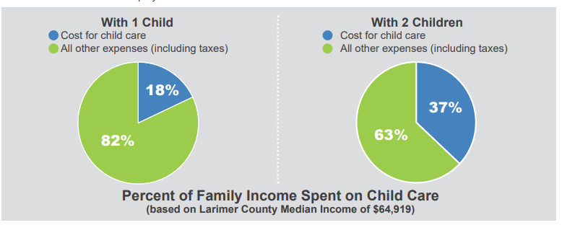
Affordability and access are major factors for families raising young children in Fort Collins and Larimer County. The average incomes for the county and city are $64,980 and $60,110 respectively. The cost of housing continues to rise, with the average cost of buying a home at $307,000.00 and median monthly rent at $1,166.00. According to Housing Catalyst, which provides housing for low income families, “residents need to earn $23.50 an hour, working full time, to be able to afford a two-bedroom rental unit in Fort Collins without spending more than 30% of their income (Homeward, 2020.)” Salary.com further explains that Fort Collins’ cost of living has increased 2.3% from last year, citing transportation, food, and housing as the largest increases. Availability of affordable housing is a challenge that came up repeatedly in the community assessment forum groups. “A lack of affordable housing, affordable childcare, and transportation are identified as structural barriers that impact family budgets. Families in Larimer County can expect to pay approximately $12,000.00 per year for each child needing care.” (Talent 2.0, 2019) Families with more than one child are even more impacted by the higher costs of childcare.
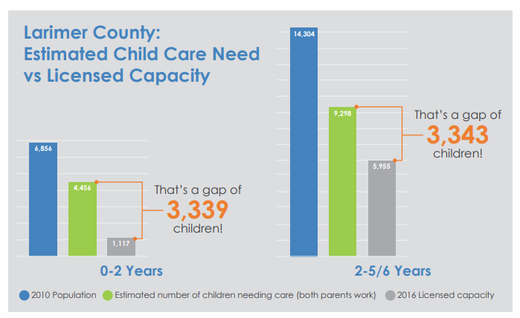
If a family were to search for early childhood care and education providers within 15 miles of Fort Collins, it would yield 364 results, yet families still struggle to find affordable and accessible childcare. The Early Childhood Council of Larimer County estimates the demand for childcare in Larimer county exceeds the supply of slots by about 6,000 children. (Talent 2.0, 2019)
In every community assessment data collection event or survey, the high cost of living in Fort Collins was a central focus of discussion. Increased availability of no-cost childcare and education slots was cited as critical to achieve early intervention and school success for students. Families shared in forums that making a decent salary meant they didn’t qualify for PSD ECE programs based on financial need. One family spoke about the experience of being directed to private speech therapy and struggling with their fears once they learned what those costs could be. Once they accessed the no-cost assessments and services in PSD ECE, their relief was huge.
While families acknowledged the benefits of living in a safe, kid-friendly community, the struggle to make ends meet was a shared experience among many participants.

Sustainability and Financial Implications
Infrastructure and service barriers created by state and local funding gaps and geographic pressures have been outlined on pages 11-17 of this Community Assessment. Addressing these barriers are central to the improvement plans of the county and the district, which will help for the future. Now, however, the PSD ECE program is called to address the needs of families amidst these barriers to access, so a detailed examination of PSD ECE financial performance follows.
Financial Performance of the PSD ECE Program
PSD ECE financial performance is shared alongside the regular Monthly Monitoring Report at each monthly Policy Council meeting. This means families and staff members are well-informed and can comment knowledgeably about budget and monthly expenditures. The increasing costs to sustain high quality education and care for families came up in multiple community assessment data sets as well as through ongoing monitoring. Within Colorado, PSD is one of the most highly sought districts in which to work. The district must maintain competitive salary scales in order to hire education staff members at this time of shortfall in education staff. Within the district, funds designated for services to students account for 87% of the total budget, and services to support schools account for the other 13% of the budget. For PSD ECE the percentage of overall budget designated to services to students is even higher. Portions of our administrative costs are directed to the PSD General Fund. This keeps administrative costs well below the 15% Head Start cap at just 7.5%, but there are no further supports to ECE from the school district General Fund.
Every PSD ECE employee is represented in annual negotiations by union representatives, and these negotiations have resulted in overall staff salary increases of 19.97% over the period of the 5-year grant. In addition to these salary figures, the increases to fringes and benefits, such as health, dental, and retirement, have been substantial over the same period. Federal and state funding increases, such as COLAs, have not kept pace with these pay increases, with Colorado increases at 15.37% over the same period and HS COLAs of just 9.4%. Recently PSD lost its competitive edge in beginning salaries, with two neighboring northern Colorado districts now having higher beginning salaries. The PSD BOE has committed to increasing the beginning salary scale to make the district competitive in hires, and once this occurs, these increases will also impact the program. In 2019-20 PSD ECE will reduce its reserves by 10% to meet salary costs. Within the next six years, program reserves will be completely depleted without finding new revenue sources.
Another annual funding shortfall occurs because the state count for funding does not take into account IFSP to IEP transitions. This means that PSD ECE receives funding for approximately 200 early childhood special education preschool slots on the state count day. However, the program enrolls 350 in any given year, typically assigning more than 50 to HS funding, and the remaining 100 served by the program unfunded. To ensure the program serves these students, PSD ECE taps into the blended funding from reserves each year, which puts further pressure on the reserve as costs for staffing increase.
A significant support to families and the program was the federal award they received to expand to support duration. While the initial funding awarded to support services beginning in fall 2017 helped the budget, subsequent shortfalls in the federal COLAs with increased services costs from expansion have hurt the program. However, PSD ECE have used every means possible to increase the number of classrooms in which children are served in full days. In Head Start classrooms 110 students are in full-day and 165 students in half-day. From state funded sources, the program now serves an additional 48 children in full days in district classrooms, and another 67 children in full days in childcare center partner classrooms. Full day services are the best-attended, easiest to fill, and most-requested by families. The program is actively seeking collaborative approaches and funding to increase to the full days, full weeks, and full years that best support families in the community.
Desire for Early Childhood to be a Part of the Elementary Experience
In community assessment forums and surveys, a repeated theme is that preschool families have varied experiences of full integration within their elementary school depending on which school their child attends. In some schools, preschoolers are invited to assemblies and school-wide events. In others, preschool classrooms host their own events. At some schools, preschool families are actively recruited for PTO or school/district-wide parent leadership groups, while others don’t yet receive regular communication from their school. These types of gaps are not reported by preschool families enrolled in childcare center partner classrooms. While PSD has made significant improvements in the full integration of preschool classrooms and elementary programming (aligned K-5 Literacy and PK Comprehensive Curriculum adoptions, formation of ECE Parent Representatives on the District Advisory Board and District Accountability Committee) there is more to be done. The community assessment process will be used to ensure that Wellington Learning System and Title ECE Feeder Schools services are co-developed by the school and county community. Over the next 5 years, it would likely benefit each school to be involved in a community assessment process to better understand the needs of the families and the staff members who serve them.

Communication
Another recurring theme was a desire for clear, timely communications. Poudre School District ECE faces some unique communication challenges because of our size and partnerships with other district departments. The complexity of cross-boundary work means that, at times, gaps in communications that originate with or between partners become part of the overall communications we manage. PSD ECE’s large, complex system serves as many students as a high school, yet services occur under many different roofs including 20 elementary schools, 7 community childcare center classrooms, and 92 homes across the PSD catchment and Larimer County. Many district departments are now integrated with ECE but depending on the depth of the integration and the clarity of work and understandings, the resulting communications can be contradictory or poorly timed. Once the gaps in communications surface, it can take time for ECE and department stakeholders to meet and improve their understandings and communications. At the same time, some communications that were carefully coordinated have had unanticipated impacts because of a need for more background information on district changes or initiatives to help stakeholders contextualize and understand. At community assessment, staff and family participants shared a desire for stronger, more timely communication that was consistent across PSD departmental partnerships.
An example from this year is the district decision to adjust the start and end times for elementary, middle, and high schools to provide later start times for older students. This decision had impacts on all areas of the system. PSD ECE communicated with building administrators to support setting the new start and end times for preschool classrooms to meet funder requirements, made decisions in partnership with Child Nutrition to ensure that snack and meal service fit within the new times, and worked with transportation to ensure transportation schedules didn’t result in missed instructional minutes for preschoolers. PSD ECE also communicated with families about new start and end times through the registration process and empowered families to make decisions about school placements based on feasibility for school and work schedules. This required types and levels of communications that were all different, because preschool classrooms were not all impacted in the same ways: some had no changes whatsoever to schedules, while other schedules changed by more than 2 hours. As the changes were rolled out in August 2019, the scale of the changes also had significant impacts on transportation, which in turn impacted the attendance and access levels of families in the program.
Also related to this year’s start and end time changes, families requested timely communication. Examples families shared were receiving information about bussing too late (or not at all), a desire to learn what classroom they were assigned sooner, and notices sent further in advance to participate in events. Families also expressed an interest in program materials more than just English and Spanish. Families commented on the program’s communication style, saying that mailing letters and phone communication was out of date, and that they preferred to receive information by text message and email. They also encouraged the use of a strong social media strategies to ensure information about the program reaches further in the community.
Recommendations and Priorities
PSD ECE leadership has synthesized these recommendations offered through our community assessment process and ranked them by priority. Some suggestions or recommendations can be found in more than one priority category. The priority categories are:
Short Term (Immediate Action) | These recommendations are immediately actionable or need to become immediate priorities. Our community can expect to see new or continued action in the over the next school year. These will be marked with a red dot.
Within the Next 5 Year Grant Cycle | These recommendations require action based on strategic planning. Our community can expect to see action on these throughout the program’s next 5-year grant cycle. These will be marked by a yellow dot.
Long Term Planning | These recommendations require action based on longer strategic planning that involves more stakeholders over the next five years and beyond. These will be marked by a green dot.
Advocacy and Awareness | These recommendations lay outside of PSD ECE’s sole influence and control. However now and ongoing, the program will advocate and seek collaborative action to promote and advance the work in these areas. This will be marked by a blue dot.

Trend/Need Identified | Recommendations
Affordability, Access and Advocacy | - Seek more tuition-based slots for families who don’t qualify for no-cost ECE to address the financial gap. Perhaps offer a sliding scale.  - Advocate for an accurate funding basis for students with identified needs served but not funded based on count date.  - Seek opportunities for full-day, full-week programming.  - Seek opportunities for wrap-around care.  - Pursue space in neighborhood schools and quality community partnerships.  - Increase collaboration, funding, and all other methods to secure transportation to help early childhood kids get to preschool.  - Continue to offer parent education classes, in multiple languages, with access to childcare during these classes.
Sustainability and Financial Implications | - Pursue more tuition-based slots.  - Seek more full-day slots that are funded federally.  - Increase state-funded slots that provide access for families for full day programming.  - Pursue other funding models to keep up with salary/cost of living increases.  - Maintain comparable wages for highly qualified staff.  - Successfully hire and retain staff members with skills valued by the ECE community such as ability to work strongly with diverse populations and languages.
Desire for Early Childhood Education to be a part of the School Experience for the child within the district | - Wellington Learning System – BOE approved strategy to provide ECE services in this geographically isolated area of high growth and poverty to ensure children are PK- and K-ready.  - Title Schools Project – BOE approved use of mill/bonds surplus to build two ECE classrooms onto5 of 6 Title One schools to  to ensure children are PK-and K-ready.  - Continue work on integrations between ECE and elementary systems through professional development, collaboration, partnerships, and community assessment.
Communication | - Marketing and recruitment for families who need our program in a variety of languages and communication models  - Update the use of social media, text messaging, emailing to better align with family needs and media capacities and efficiencies.  - Communication about early intervention Services  - Timely communication with families with consistent messages across the system.

References For Poudre School District Community Assessment

2020, H. (2019, May). Fort Collins Homeless Solutions Community Forum. Retrieved from Homeward 2020: http://www.homeward2020.org/resources/
Bustang. (2018). Ride Bustang. Retrieved from Bustang and Colorado Department of Transportation: www.ridebustang.com
Colorado Children's Campaign. (2018, March). Colorado Children's Campaign. Retrieved from 2018 Kids Count: https://www.coloradokids.org/data/kids-count-archive/2018-kids-count/
Colorado Department of Education. (2019, January 24). Colorado Department of Education. Retrieved from Student Enrollment Growth in Colorado: http://www.cde.state.co.us/communications/20190124enrollment
Early Childhood Council of Larimer County. (2018). A Workforce Strategy and Major Economic Driver: Child Care in Larimer County. Fort Collins: EPIC: Executives Partnering to Invest in Children .
Fort Collins: Geography and Climate. (n.d.). Retrieved from City-Data.com: http://www.city-data.com/us-cities/The-West/Fort-Collins-Geography-and-Climate.html
Garcia, S. -U. (2019, July 24). United Way of Weld County. Greeley, CO.
Jay Swope - Larimer County DHS. (2019, 6 28). Interim Casework Supervisor - Foster/Kinship. Fort Collins, CO.
Kyle, S. (2017, April 17). Homeless Count. Retrieved from Coloradoan: https://www.coloradoan.com/story/news/2017/04/06/2017-count-sheds-light-fort-collins-homeless-youth/99820986/
Poudre School District. (2018). Poudre School District. Retrieved from PSD Enrollment and Demographics: https://www.psdschools.org/your-district/about-psd/enrollment-demographics
Poudre School District. (2018). Poudre School District . Retrieved from Your District : https://www.psdschools.org/your-district
Poudre School District. (2019). Program Information Report. Fort Collins: Child Plus.
Salary.com. (2019, 8 27). Retrieved from Cost of Living Calculator: https://www.salary.com/research/cost-of-living/fort-collins-co
Swope, J. (2019, 6 28). Interim Casework Supervisor - Foster/Kinship. (C. Martin, Interviewer) Fort Collins, CO.
Talent 2.0. (2019, January). Child Care in Larimer County. Retrieved from Early Childhood Council of Larimer County: https://ecclc.org/app/uploads/2019/02/Talent-2.0-Child-Care-Task-Force-Report.pdf
Transfort. (2014). Transfort - City of Fort Collins. Retrieved from Ride Transfort : www.ridetransfort.com
Trust for Learning. (2019). Retrieved from Parents as Consumers of Early Education: https://trustforlearning.org/parent-research/
United States Census Bureau. (2017). Language spoken at home 2013-2017 American Community Survey 5-Year Estimates. Retrieved from American Fact Finder: https://factfinder.census.gov/faces/tableservices/jsf/pages/productview.xhtml?src=bkmk
United States Census Bureau. (2018, July 1). Retrieved from Quick Facts: Larimer County, Colorado: https://www.census.gov/quickfacts/fact/table/larimercountycolorado#
United States Census Bureau-Quick Facts Fort Collins city, Colorado. (2018). United States Census Bureau. Retrieved from Quick Facts Fort Collins city, Colorado: https://www.census.gov/quickfacts/fortcollinscitycolorado

Acknowledgements
Poudre School District Early Childhood would like to acknowledge the following people who supported the data collection, writing, and implementation of this report and its findings.
Program Participants – Thank you to all the families who contributed to this report and its contents. You make the story of our children and program come alive.
Community Members and Partners – Thank you to Beverly Harris, a community member and program grandmother who helped co-facilitate the community focus groups. Thank you also to community members who participated in this process to offer ideas, suggestions and invest in the children in our community.
PSD ECE Instructional Staff – Thank you for participating in table discussions, sharing your stories, providing critical insight and working with families and children to make dreams a reality. Your connections with families make these relationships and rich conversations possible.
PSD ECE Operational Staff – Thank you for being the face of Early Childhood when families come to us for the first time. Thank you for your support with organizing meetings, confirming attendance, working on childcare, and taking care of all those details.
PSD ECE Leadership – Thank you for your guidance, research, and investment in children and their families. This leadership team includes: Carolyn Martin, Director of Early Childhood Education; Candace Martin-O’Connor, Assistant Director of Early Learning; Becca Benedict, Operations Manager; Sharon Weaver, Quality Data Assurance Technician; Nikki Arensmeier, Family and Community Engagement Coordinator; Sarah Weible Eligibility, Recruitment, Selection, Enrollment, and Attendance Coordinator; Stephanie Hahn, Disabilities Specialist; Elizabeth Dunne, HR and Finance Technician; Nancy Weber, PSD Health Coordinator
PSD ECE Policy Council Executive Committee members and Program Representatives: KJ Hosman, Keisha Stallings, Justin Berling
PSD Board of Education President Christophe Lefevre and ECE liaison Naomi Johnson.
PSD central administration, including Superintendent Dr. Sandra Smyser, HS Executive Director and Assistant Superintendent of Elementary Schools, Todd Lambert. We also want to thank our departmental partners within the district. We couldn’t do this work without the support from all the buildings, departments, and district employees.

