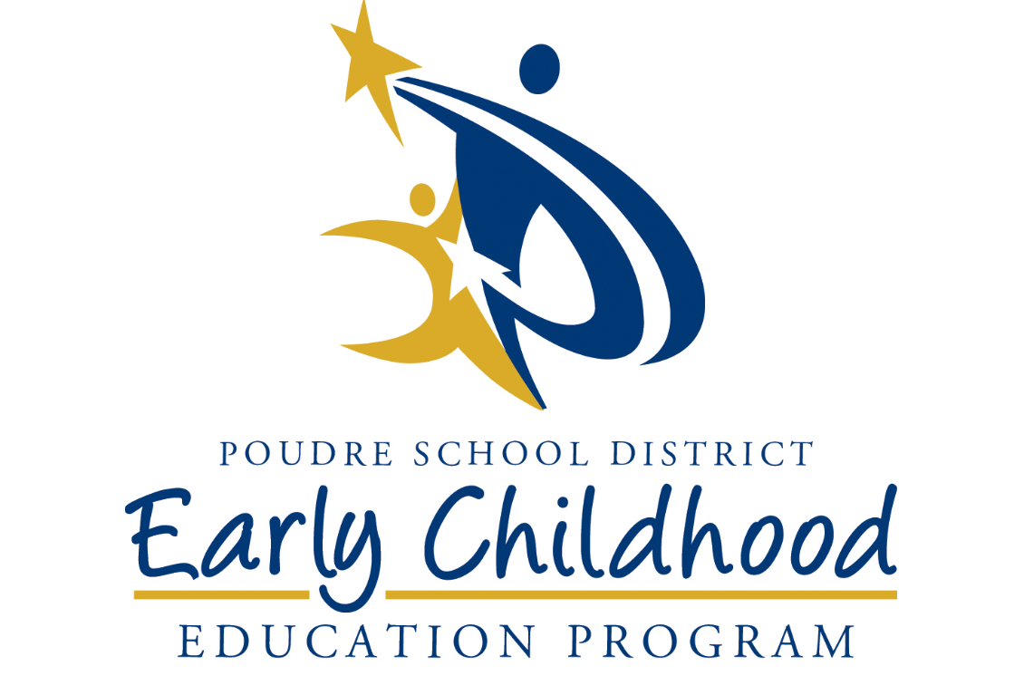

2021-2022 Early Childhood Education Parent Handbook
Thank you for the privilege of working alongside you, and welcome to the 2021-2022 school year.
This handbook contains lots of useful information, so please use it often. When you want to know more about your family’s opportunities and responsibilities in Early Childhood, look within these pages.
You are your child’s first, most important and most lasting educator. We encourage you to actively advocate for what is best for your child and family We encourage all parents to attend monthly Early Childhood Your Voice governance meetings at Fullana Learning Center to ensure that the Early Childhood program makes decisions that reflect your lived experience. You are already a voting member. Plan to be part of your school/center by participating in Parent Teacher Organizations (PTO) and School Accountability Committees (SAC), as well as at social and learning events.
The first day of Early Childhood is August 23, 2021 with center visits the week before as a staggered start. Your teacher will have more information about the schedule as it gets closer to the beginning of the school year. If you have a Family Mentor, visits will begin in late July (Early Head Start) or late August (Head Start).
Count on Us. We are partners, as are all the staff members at each school or center your child attends. As your family and child change, please let us know about your needs. We provide parent education, guidance, and referrals to support you, and we do it best when we do it together.
We look forward to collaborating with you for the best outcomes for your family in the 2021-2022 year ahead,
Becca Benedict
Director
Preschool Attendance Reporting Line:
970-490-3336
Program office:
Fullana Learning Center
220 North Grant Ave.
Fort Collins, CO 80521

Program information:
Email: psdece@psdschools.org
Phone: 970-490-3204

The Purpose and Philosophy of Poudre School District Early Childhood Education

PSD MISSION STATEMENT: Educate Every Child, Every day.
EARLY CHILDHOOD EDUCATION MISSION STATEMENT: We exist for our community’s most vulnerable families. We ensure that all our enrolled children are ready for and will be successful in Kindergarten.
EARLY CHILDHOOD EDUCATION VISION STATEMENT: We empower our community’s eligible children and families to build a foundation for learning as measured by their readiness for kindergarten and beyond.

Early Childhood Contact Information
Becca Benedict
Director of Early Childhood Education – 970-490-3254

Candace Martin-O’Connor
Assistant Director of Early Learning – 970-490-3082

Sharon Weaver
ERSEA Coordinator (Enrollment, Recruitment, Selection, Eligibility and Attendance)– 970-490-3036

Nikki Arensmeier
Family and Community Engagement Coordinator – 970-490-3188

Stephanie Hahn
Disabilities Coordinator – 970-490-3102

Jack Robertson
Finance and Human Resources Technician – 970-490-3360

(To be hired)
PSD Health Coordinator – 970-490-3388

Important Information
Early Childhood Attendance Reporting Line: 970-490-3336
Bus Transportation: 970-490-3232
School or Center: _________________________________________
School or Center Phone Number: ____________________________
Teacher’s Name: _________________________________________
Teacher’s phone: _________________________________________
Teacher’s email: __________________________________________
Head Start or Early Head Start Family Mentor’s Name: _______________________________________________________
Phone Number: __________________________________________
School or home visit start time: _____________________________
Principal Name: __________________________________________
Assistant Principal Name: __________________________________

Other important School Information for Quick Reference:
___________________________________________________________________________________________________________________________________________________________________________________________________________________________________________________________________________________
Table of Contents
PROGRAM DESCRIPTIONS
Parent Calendar | p. 6
Application, Eligibility, and Enrollment | P. 8
School Age Enrollment | p. 8
Attendance Area | p. 8
Map of Schools | p. 9
Poudre School District and Early Childhood Communications with Parents | p. 10
Highlight: Early Head Start Parent and Child Together (PACT) Events | p. 10
Parent Opportunities  - Your Voice  - Parent Policy Council  - Program Wide Pacts  - Volunteering  - Parenting Classes  - Family Engagement Opportunities | p.11
IMPORTANT PROGRAM INFORMATION
Transportation  - Eligibility for Transportation  - Parent Partnership Expectations from Transportation Contracts  - Requirements of Students and Families if Assigned a Bus Route | p.14
Attendance  - The Attendance Line and Parent Procedure  - Importance of Attending School  - Weather Related Information  - Attendance Support and Enrollment requirements | p.18
Health Services  - When to Keep Your Child Home from School or Childcare  - Health and Dental Services  - Family and Mental Health Support | p.20
PROGRAM POLICIES AND PROCEDURES
Accident, Illness and Injury | p.26
Diapering and Toilet Training | p.26
Emergency and Disaster Preparedness | p.26
Field Trips | p.30
Many Ways to Learn: In Person and Remote Instruction | P.30
Guidance, Discipline and Positive Behavior Support | p.31
Special Education (Integrated Services) | p.31
Notice of Non-Discrimination | p.31
Complaints | p. 32
Suspension and Expulsion | p. 32
Reporting Child Abuse | p. 32
Reporting Preschool Licensing Violations | p. 32
Fees | p. 32
School Meals and Snacks | p. 33
Medication | p. 34
Pick Up Policy | p. 34
Release Authorization | p. 34
School Cancelation | p. 35
Visitors | p. 35
Volunteering | p. 35
Smoking | p. 35
TV/Videos | p. 36
TV and Media Opt Out | p. 36
Weather | p. 36

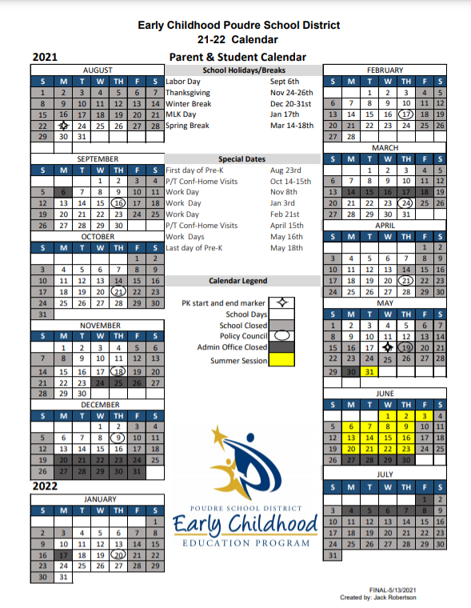
A downloadable copy of this calendar can be found at psdschools.org/programs-services/early-childhood-education under ECE Resources.

Program Descriptions

Application, Eligibility, and Enrollment
Families interested in the program must first submit a program application with supporting documents to the Enrollment team. Families must also complete our screening survey, the ASQ – 3 and the ASQ – SE and return them during the application process. An Enrollment specialist will contact the family by email, postal mail, or phone for follow-up and/or application status.
Poudre School District (PSD) Early Childhood Education has the following funding options for prenatal through 5-year-old program enrollment no-cost to families: Early Head Start (prenatal through 3 years), Head Start, Colorado Preschool Program, and Early Childhood Special Education. There are also a limited number of tuition-based slots. Each funding source has its own criteria for eligibility. Once eligibility is determined, every child is placed on our waitlist.
Once on the waitlist, an Enrollment Specialist will schedule a child for vision and hearing screening appointments. At the appointment, the ASQ survey results will be discussed and any questions the family may have can be asked and answered. Children may be enrolled with immunizations that are up-to-date or exempt due to the family’s religious and personal beliefs. In the event of an outbreak of disease against which immunization is required, non-vaccinated students may be excluded from school.
Placements from the waitlist are determined based on the family need, and are not on a first-come, first-served basis. When a placement becomes available for a waitlisted child, the family will be offered the spot and the child will be enrolled. Classroom placements offered to your family may be in a PSD elementary school or with one of our center-based partners.
Staff are notified by email when a student withdraws from the program. If a student is dropped (not because of a parent request) parents will be informed in person and/or in writing.

School Age Enrollment
Children applying for PSD Early Childhood Education preschool must be age three or four on or before October 1 for Colorado Preschool Program and Tuition Based funding. Children ages birth to three years old may be enrolled through Early Head Start with actual age enrollment. EHS students may transition to PreK Head start at actual age 3. Children ages three through five years old may be enrolled if they qualify for Integrated Services (Special Education) with actual age 3 enrollment.

Attendance Area
Families interested in preschool enrollment with PSD Early Childhood preschool must live within the PSD attendance area. No exceptions will be made. If a child moves out of the district attendance area before classes begin for the year, the child will be disenrolled and the family will be referred to the programs within their new attendance area. If a family enrolled in preschool moves out of district during the school year, the child may continue to attend until the end of the current school year. However, any district transportation will be cancelled, and the parent will be expected to provide transportation. Home visiting will be provided within the PSD attendance area. Children living out of district will not be eligible for re-enrollment.
Families who are enrolled in Early Head Start (prenatal through 3-year-old) must live within Larimer County. Families who move outside the county will be disenrolled from the program. Please see the map on the following page.

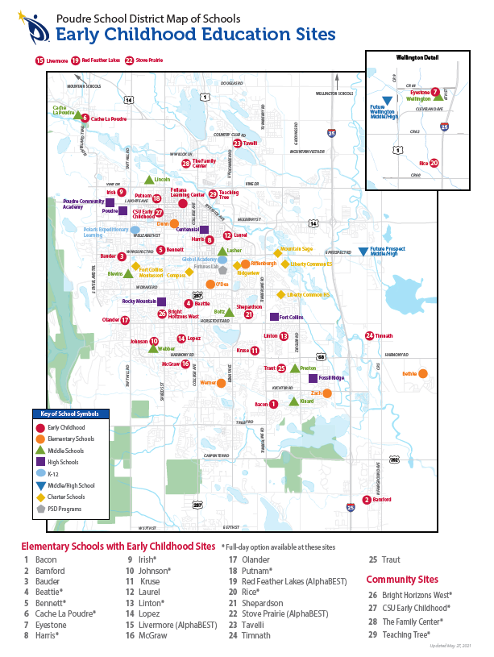

Poudre School District and Early Childhood Communication with Parents

Our website is: bit.ly/PSDpreschool
On our website you will find Early Childhood information, links to program forms and applications, information about our parent-governed program, our grant information, and many other family resources.
You can also “like” us on Facebook or Instagram at Poudre School District Early Childhood.
Other District Communications
PSD uses the SchoolMessenger automated phone system to call parents at schools with emergency information or important upcoming events and opportunities. Contact Fullana at (970) 490-3204 to update your phone number.
As a registered/cleared volunteer, you will receive email messages from SchoolMessenger telling you about upcoming volunteer opportunities.
Early Childhood Communications
The Early Childhood program may contact you via emails, text messages or postal mail. Please make sure your current email and phone numbers are listed and update them as needed. Please check your email SPAM folders in case news is filtered out of your inbox.
If you child attends preschool in one of our community partner center sites, each site may have a different plan for communication. Please check with your child’s teacher and/or site director regarding expectations for communication.

Highlight: Early Head Start
Poudre School District Early Childhood Education has Early Head Start (EHS) services for expecting mothers and families and children birth to three years of age. The EHS program offers prenatal and parent education support during and after birth and for the all-important first three years of your child’s life. The EHS options are home-based and center-based and both options include home visits with your assigned family mentor. For the majority of enrolled prenatal woman and children up to age three, home visiting occurs once each week. Your family mentor will discuss your schedule for home visits with you. Our limited spaces in the center-based option consists of daily care in the licensed infant/toddler center and monthly home visits.
During home visits, families and family mentors work together as a team on each child’s development, family development, program involvement, goal setting, child and family health, plus much more. In the Early Head Start program, each child will receive developmental, hearing, and vision screenings as well as on-going developmental assessments. We can assist families with referrals when your child’s development is of concern and we have partnerships with service providers for children with Individual Family Service Plans.
Families and children may also participate in monthly socialization opportunities called PACT (Parent and Child Together) events. These include:
- Opportunities for parents to participate in activities that support their parenting skills development or family partnership goals.
- Opportunities to interact with other parents and caregivers.
- Opportunities to observe and actively participate in activities.

Parent Opportunities
We encourage our families to be involved, become advocates, and volunteer. Please consider the opportunities and talk to your mentor, teacher, principal, or director about those that may interest you.
Your Voice: Families and Community Together
Get involved in your child’s education by joining YOUR VOICE: Families and Communities Together. This group is directly responsible for oversight and governance of the Early Childhood Program. Once enrolled you are already a voting member. When you attend one of the monthly meetings, you will review and approve policies, budgets, grant information, program calendars, and much more! Meetings are the third Thursday from September through May at Fullana Learning Center, 220 N Grant Ave. Child care and dinner are provided at 5:30, and the meeting begins at 5:45. Please make plans to attend this important meeting and get involved in your child’s education today. Your input and suggestions are important and help make our program great. Questions? Please call Fullana Learning Center at 970-490-3204 for more information.
You can also participate in Your Voice by serving in one of the Your Voice Leadership roles such as Chair, Co-Chair, Secretary, and Classroom representative. Elections for these positions occur in October.
The dates for Your Voice are on the program calendar and set for the remainder of the year so you can plan to be there.
Special Events
Be a part of a team that helps plan and organize special events within the program. Meets as needed for planning special events in the program or in the classroom.
Outreach and Recruitment
Help us reach out to families and children who may be interested in the program. Word of mouth and sharing your experiences in the program is often our best recruitment tool. Share your experiences and invite other families to apply.
EC Program Committees
Committees provide parents the opportunity to participate in focused work throughout the year as they form.
Parent Governance
Act as a representative for your class, school, center, or Family Mentor! Attend your school’s monthly meetings regarding important decision making. Check with your school for dates of Parent Teacher Organization (PTO) or School Accountability Committees (SAC) meetings. At school meetings, report back to classroom teachers and families on Your Voice discussions and decisions.

Classroom Volunteers
Help your child’s classroom in a variety of ways: reading aloud, preparing materials, attending field trips, or helping with a small group of children. You will need to follow PSD’s Volunteer registration process to be cleared to volunteer regularly in the classroom or school.
Health and Safety for Volunteers
All volunteers should be healthy and free of illness when working in the classroom or going on field trips. Illness includes but is not limited to cold, sore throat, cough, or any stomach illness. When volunteering in the classroom, take some time to familiarize yourself with the classroom and/or school safety rules. Certain materials should be monitored closely. These items include scissors, sand, glass items, pointed objects, and cooking utensils. Never allow a child to use a paper cutter, adult scissors, or handle hot dishes.
In times of pandemic, the Early Childhood program will follow all current safety regulations for childcare from the Colorado Department of Public Health and Environment and the Colorado Department of Human Services. Your child’s teacher or school/center administrator will let you know what these guidelines are. Such requirements could include (but are not limited to): temperature check, daily health screening, mask requirements, or other safety precautions such as proof of vaccination.

Parenting Classes
Our program offers a parent education classes that focus on helping you and your child develop strong social emotional bonds and skills. The classes are offered in Spanish and English and provide strategies for addressing challenging behaviors, because all children have challenging behavior some of the time.

Parent Engagement Opportunities
PSD Early Childhood Education provides family engagement opportunities at schools as well as in the community. You may take advantage of your school’s/center’s literacy nights or other family events as well. PSD Early Childhood Education has partnered with the Fort Collins Museum of Discovery (FCMOD) to provide free membership to FCMOD so you can enjoy visits to the museum year-round. We have also partnered with The Gardens on Spring Creek to offer a yearly membership for your family as well. Ask your teacher or mentor about the City of Fort Collins Parks and Rec discount so you can enjoy swimming at the city’s pools among many other activities and classes. At the end of the school year, we provide a calendar of free/low costs events for the summer to keep your family involved in the community and continue fueling your child’s learning.

IMPORTANT PROGRAM INFORMATION

PSD Bus Transportation
Numbers for Transportation
To apply for a bus, check on a transportation, application, or with general questions, please call 970-490-3204
To report that your child will not be riding the bus: 970-490-3232
In order to qualify for a bus, ECE students enrolled in no-cost funding are eligible to apply. Families must be attending their neighborhood school AND live more than one mile from that school to be eligible to apply for busing. All bus students must register prior to June 24, 2021 to be eligible to receive a bus by the beginning of school. Transportation is awarded on a space-available basis and is not guaranteed. Families may apply for busing at any time to be awarded on a space-available basis after the school year deadline has passed.
Not all Early Childhood students qualify for transportation. Families are encouraged to apply for busing if they are placed in their neighborhood school or have an Individual Transportation Plan (ITP) included with their special education Individualized Education Plan.
We encourage families who need transportation to apply as early as possible.
In times of pandemic or health crisis, it is possible that the district will be required to limit transportation further to comply with public health regulations. Current information regarding busing and public health requirements will be updated on the district’s transportation web page. https://www.psdschools.org/programs-services/transportation

Transportation Expectations and Contract
Parents and Guardians of children who applied for transportation services must complete a transportation contract. This contract is included in your transportation request application and is initialed and signed by families who are applying for transportation.

PSD ECE Transportation Agreements

For Special Education Students transportation is provided in the Least Restrictive Environment whenever possible; however, the bussing route may determine where the preschool student will attend to receive their services.

Students within the 1-mile radius are within the walk area and will be scheduled to walk to school.

It can take up to 10 school days for transportation services to begin. It may be longer in high application volume times or pandemic. Transportation is awarded on a space-available basis.

PSD busses are not able to pull down into cul-de-sacs or some narrow/dead end roads to pick up students; furthermore, if your student lives in the regular bussing area he/she will be assigned at the regular bus stop.

If your student requires transportation in a wheelchair or other mobility device, it will need to be approved by transportation for safety.

If a family is in the process of moving or changing where a child is picked up and dropped off, school placement /transportation may change.

To participate in transportation which may be provided, families are responsible for getting their preschooler to the assigned pick up location and for meeting the bus at the assigned drop off location. Preschoolers must be attended by a responsible and assigned adult.

To participate in transportation which may be provided, families are responsible for getting their preschooler to the assigned pick up location and for meeting the bus at the assigned drop off location. Preschoolers must be attended by a responsible and assigned adult with identification.

If no authorized individual is present at bus stop and child is returned to school on three occasions, bus privileges will be canceled.

Authorized individuals with identification will be required to sign for the student each day that the child rides the bus. These individuals must be identified and in the Child Plus information system.

The addition of other authorized individuals must be completed in writing and will take at least 5 days for the individual to be added to the authorized pickup list.

Busing Complaints
Parents who have complaints regarding your child’s bus must first please speak with the bus driver to problem-solve. If speaking with the driver does not solve your program, please speak to the Enrollment team at 970-3254.

Bus Drivers
Bus drivers are trained in emergency procedures and teach those procedures to the children. In the case of emergency, the driver and other PSD staff will stay with the children until the parents or emergency contact is notified.

Bus Stop
The child and adult must be within view at the bus stop for the bus to stop for pickup. Otherwise, it will continue along the route without stopping. The bus will not wait, honk its horn, or call to let you know it is outside waiting. It is important to NEVER leave a preschool child unattended at the bus stop. An adult or sibling over the age of 16 years old must always be with the child. The district offers an app called “Here Comes the Bus” that you can download to track the bus in live time. You can find the app at https://www.psdschools.org/programs-services/transportation/live-bus-updates. Follow the steps to create your account to get more information about this app.

Cancellation of Transportation Services
Students who are not picked up from the bus stop three times during the school year will have bus services cancelled by the Transportation Department. (See Release Authorization for more information). Bus service will also be cancelled if a family member is verbally or physically threatening to the driver, a child, or other families on the bus or at the bus stop. To have cancelled transportation services resumed, the family must first meet with the Program leadership and Transportation Department staff to discuss a Transportation Plan.

Bus Pick Up
An adult at least 16 years of age with identification must be waiting with the student at least 5 minutes before the scheduled bus pick up time. If the adult and child are not within view of the driver at the bus stop, the bus will not make the stop and will continue along the bus route without the student.

Bus Return
An adult at least 16 years of age must be waiting for the student at least 15 minutes before the scheduled return time. This is in case of last-minute changes in the bus schedule, bus route and/or bus driver. The bus driver is responsible for verifying the photo identification of the authorized adult who takes the child from the bus. The driver will not allow the child off the bus with an unauthorized adult, an adult without an ID, or if no adult is present.
If no adult is present, the child will not be allowed to get off the bus. The bus will continue along the route and return the child to their child’s school. It is the responsibility of the parent/guardian to meet the bus back at school and sign their child out. If the parent is not at the school, the school will attempt to contact the parent/guardian and emergency contacts. If they are unable to reach any emergency contacts within 30 minutes of the return to the school, they will call law enforcement and the Department of Health and Human services, Child Protection to work with them to ensure you child is returned safely to you.

Release Authorization
Children will ONLY be released to adults at least 16 years of age and listed on your child’s Emergency & Release To list. Call the Enrollment team at 970-490-3204 to update your Emergency and Release To list. To add someone new to the list, you will be asked to fill out a data change form with the new information, and your signature. Please plan ahead as last-minute changes to Emergency and Release To lists are difficult to communicate to EC departments, transportation, and driver without notice.
The Fullana Staff must have a copy of any applicable restraining orders on file to enforce them.
Authorized adults must provide a photo ID. The staff and bus driver are required to verify the photo ID of the authorized adult. If the authorized adult is not at the bus stop, or does not provide the picture ID, the bus driver will not release the child and will continue on the route and return the child to the school at the end of the route. Please call PSD TRANSPORTATION DISPATCH at 970-490-3232 to get more details about where and when your child will be returned. If we are unable to reach emergency contacts within 30 minutes of the bus return, we will call law enforcement and the Department of Health and Human services, Child Protection and work with them to ensure that your child is safely returned to you.

Request for Parents Riding PSD Buses
Parents who are interested in riding the bus with their child must complete a Request for Parent Transportation form and return it to the Enrollment Team. This will be allowed only if space is available. Allow for 14 days for requests to be processed.
All parents are welcome to ride bus if they are approved as a chaperone/volunteer on field trips.
All requests must be approved by the Early Childhood Director and the Director of Transportation.

Seatbelts/Safety Vests
All preschool students who ride a Poudre School District bus to and from school will be buckled into a safety vest during their trip.

Siblings Riding PSD Buses
Children who are not enrolled in Poudre School District are not allowed to ride a Poudre School District Bus.

Transportation Changes
All busing changes require 7 to 14 days to be processed. Call the Enrollment team for any busing changes or cancellations. You will be asked to fill out a data change form. While we try to accommodate busing requests, requesting a change does not mean your students will be automatically reassigned. Bus placements are made on a space-available basis and will be made only for children who are eligible for EC transportation.

When your Family Does not Need Transportation for the Day
IF your child does not need to ride the bus to school for the day, you must inform PSD Dispatch at 970-490-3232 as early as 6:00 a.m. but no later than one hour before your child is scheduled for pick up to cancel the route for the day. It is important also important to call the Early Childhood Attendance Reporting Line at 970-490-3336 to report the absence.

Attendance

Why is it so important to attend preschool every day?
Learning is a progressive activity. Each day’s lesson builds on lessons from previous days and regular student participation in learning plays a significant role in your child’s success at school.

How many days absent are too many?
Children who miss more than 2 days per month are considered chronically absent. Children with chronic absenteeism are more likely to have lower test scores in 3rd grade and less likely to graduate high school. To avoid chronic absenteeism, make sure you have a backup plan to get your child to school.

Tips for getting to school each day, on time:
- Set a bedtime routine to allow enough rest for your child.
- Lay out your child’s clothes the night before.
- Pack your child’s backpack the night before.
- Set your morning routine to allow enough time for your child to get ready and eat a healthy breakfast.
- Make getting ready and going to school fun by singing songs, making up stories, and getting excited about school.
Preschool is the best time to build a habit of good attendance.

Preschool Attendance
Daily attendance is taken in your child’s classroom and late arrivals and early pick-ups are recorded as well. Please call the attendance line as soon as you know your child will be absent and before your session begins. The attendance message line is 970-490-3336. Childcare licensing requires us to track illness symptoms. When you call the attendance line, you will be asked to provide the following information:
- Child’s first and last name (spell the child’s last name)
- Student’s date of birth
- School name
- Teacher name
- Reason for absence. (Briefly let us know the reason your child is absent)
- If your child is sick, please leave a description of their symptoms (abdominal cramps, chills, diarrhea, fever, headache, muscle aches, rash, vomiting/throwing up or other)
In times of a pandemic or health crisis, you may be asked to provide further information. Health precautions that may be in place include daily symptom screening, temperature check, or verification from a doctor that your child is well enough to return to class. Notifying the classroom does not excuse an absence, please make sure you are calling the attendance line.

No Call, No Shows
Any absence that is not called in to the attendance line 490-3336 is considered a no-call, no show. (Please note: calling the teacher does not mean you have called in the absence to the attendance line.) Please call the attendance line and let us know the reason for your absence so that we know your child is not lost or in an unsafe situation. You will be asked to share your child’s symptoms and may be contacted for follow-up. This is a licensing requirement for the program. When we do not receive a call from you about your child’s absence, we will contact you to follow up, usually by text message within hours to monitor the child’s safety. Any no call, no show will be recorded as an unexcused absence. Repeated no-call, no shows will lead to support from the Early Childhood staff and administrators and could include an attendance plan.

Attendance Follow-Up and Attendance Plans
Our attendance goal is to have 95% or better attendance, and we often see much higher numbers than that goal!
PSD ECE monitors and report attendance monthly to our funders. Monthly, if your child’s absence rate falls below 90%, an ECE staff member will conduct an attendance review. After the review, you may have conversations with your child’s teacher or family mentor so that they can offer support with problem solving and check in again about your child’s attendance. If the attendance check reveals low attendance more than two months in a row, your child’s teacher or mentor will refer your family to the Attendance Impact Team. We will work with you and your family to help you find ways to eliminate barriers related to accessing school. Follow ups will be assigned and monitored to support your family.
If your child’s attendance rate has fallen below 60%, it is time for the attendance team, including your family and program administration, to consider if your child is benefiting from preschool education. Frequent, chronic absences (unexcused or excused) lead to disruption in student routines and schedule. We will review your attendance follow up and ask to meet with you to form an attendance plan. Most of our families who start on an attendance plan are back on track within a couple of months. However, if you are unable to meet the goals of your attendance plan, your child may lose their funded slot for preschool and it will be given to another child on our waitlist.
In the event of a health crisis or pandemic, attendance policies will be revised to support healthy decisions and best practices to keep your child safe and healthy.

Weather-Related Information and Attendance
PSD uses many methods to communicate with parents in emergencies, such as school closure due to weather. Information is shared on the PSD website, social media, School Messenger phone messages, parent email, staff mail, and social and traditional media outlets. Sign up to receive PSD and school emails by clicking on the Email alert sign up link on the Parents link at the top of the PSD website. For the latest and most accurate information about PSD weather related closures or delays, visit the PSD website, www.psdschools.org.
Please keep your email and phone information up to date. If you have changes to your information, please submit a data change form to Fullana Learning Center or psdece@psdschools.org.

Other Attendance Information
Absences are marked excused or unexcused. Excused absences include illness, medical appointments, family crisis, or other reasons pending approval of the ECE administrators. Unexcused absences include travel while school is in session, transportation issues, or taking a day off.
Ten or more days of unexcused absences in a row without communication from the family will cause disenrollment from the program. If a family wishes to disenroll, they are asked to call, notify in person, or send a letter to the Enrollment Department or their child’s teacher with their intent to disenroll their child.
Extended absences (absences of more than 5 consecutive days) must be reported in advance and approved by the Enrollment Coordinator. This will help you avoid disenrollment.
Be sure to contact the Transportation Department at 970-490-3232 if your child will not be riding the bus due to extended absence.

Confidentiality
All child and family records are kept confidential. Release of information is only given with authorized consent and with the approval of the family.

Health Services

Well-Child Exams and Immunization Regulations
In the Early Childhood programs, there are health care and dental care requirements that parents must complete for your child’s participation in the classroom. Please be responsive to requests for annual physical health exams, lead blood testing (Head Start and Early Head Start students), annual dental exams, and current immunization records. These are also required for your child’s health file by Colorado Department of Public Health and Environment and Human Services for our licensed classrooms to remain open.
All children in Early Head Start must maintain a current immunization record with physical exams (well-child checks) at 2, 4, 6, 9, 12, 24, 30, and 36 months. Children are required to have a lead blood test at one to two years of age performed at their medical home clinic. WIC does not provide lead testing. Children must also have an annual dental exam starting at one year of age.

Family Mental Health Support
The Early Childhood Mental Health Specialist is available to assist families in the area of mental health. Services include:
- Support for families with behavior and/or mental health concerns about their children or family members.
- Referrals to school psychologists as well as to outside agencies for continued, on-going support.
- Observation, coaching, and/or recommendations on next steps and ideas for support.
Referrals can be made to ECE Mental Health Specialists by contacting your child’s teacher or family mentor. If you would like to make a confidential referral, please go to: https://www.psdschools.org/programs-services/early-childhood-education

Vison and Hearing Screening
Vision and hearing are completed annually while your child is enrolled in the PSD Early Childhood Program. If there are concerns with either vision or hearing, parents will be notified, and a plan will be made for re-screening or a referral if needed.

Dental Health Services Overview
The Poudre School District ECE program has dental staff that coordinate dental services for children within the program. Services offered include:
- Assistance with follow up and treatment with local dental practices.
- Dental Education and teeth brushing in the preschool classroom when allowable.
- Support to find a dental home for regular treatment and care.
Health and dental records may be given to your family mentor, teacher, dropped off or faxed to the Fullana Learning Center at 970-490-3134. For EC health related questions, please call us at 970-490-3101.

Licensing Requirements and Follow-Up
Your child will attend class in a licensed classroom. Licensing requires certain medical and dental requirements. If your records become expired, you will be asked to follow-up to maintain a student file that meets licensing requirements. If you receive a call from an ERSEA tech, Health or Dental Tech, please respond to those requests as soon as possible.

Is Your Child Too Sick to Attend Preschool?
Please use the Children’s Hospital of Colorado’s How Sick is Too Sick? Illness Policy for Parents as your guide as to when you should keep your child at home because of illness. This helps us meet child care licensing guidelines. We maintain the same standard for staff as for students.
When to keep your Child at home from School or Childcare
There are three main reasons to keep sick children at home:
- Your child does not feel well enough to take part in normal activities
- Your child needs more care than teachers and staff can give while still caring for other children.
- The illness is on the list and staying home is recommended.

Children with these symptoms or illnesses should be kept at home and excluded from school:
Symptoms or Illness | Child Must be Kept at Home
Diarrhea  Frequent, loose, or watery stool (poop) compared to the child’s normal ones that are not caused by food or medicine. | Yes  If the child looks or acts sick, has a fever, is throwing up or has diarrhea, or diarrhea cannot be contained in the diaper or toilet.
Fever  With behavior changes or other illness. | Yes  If the child has a rash, sore throat, is throwing up, has diarrhea, behavior changes, stiff neck or difficulty breathing. To return to school, the fever needs to be gone without using fever reducing medicines for at least 24 hours.
Flu-Like Symptoms  Fever of over 100 degrees with cough or sore throat. Other flu symptoms can include tiredness, body aches, throwing up and diarrhea. | Yes  For at least 24 hours after the fever is done without using fever reducing medicine.
Coughing  Note: Children with asthma may go to school with a written health care plan and the school is allowed to give them medicine and treatment. | Yes  If the coughing is severe, uncontrolled OR your child has wheezing, rapid breathing, or trouble breathing, and medical attention is needed.
Mild Respiratory or Cold Symptoms  Stuffy nose with clear drainage, sneezing or mild cough | No  Your child may go to school if they are a able to take part in normal school activities. Keep your child at home if symptoms are severe, child has a fever, or is not acting normal and cannot participate in activities.
Rash | Yes  Rash with fever, call your doctor. Any rash that has spread quickly and/or is not healing should be checked by a doctor.  No  Rash without a fever. A body rash without a fever or behavior changes usually means your child does not have to stay home from school. You can call your doctor for advice.
Vomiting/Throwing Up  Throwing up two or more times in the past 24 hours. | Yes  Until the throwing up stops or the doctor says it is not contagious. If your child has recent head injury, watch for other signs of illness and for dehydration.
Chicken Pox | Yes  Until the blisters have dried and crusted (usually about 6 days)
Conjunctivitis (Pink Eye) | No  Children do not need to stay home unless they have fever or behavioral changes. Call your doctor for advice and treatment.
Head Lice or Scabies | Yes  From the end of the school day until after the first treatment.
Strep Throat | Yes  For 24 hours after starting antibiotics unless the doctor says it is okay to return to school sooner. Your child should stay home until they can participate in usual activities.

In times of pandemic or health crisis, Poudre School district will follow all public health guidelines to ensure the safety and well-being of students and staff. An additional health screening or a health questionnaire may be required. Remember the best way to stop the spread of infection is through good hand washing.
Poudre School District has up-to-date guidance for returning to the classroom after an illness, particularly if it is a COVID related symptom. At times, if there is an exposure in the classroom, the classroom may be shifted to remote instruction until it is safe for the students to return.

Programs, Policies, and Procedures

Accidents, Illness, and Injuries
If a child becomes ill while at school, the parents (or emergency contact if the parents are not available) will be notified and asked to pick up the child. Children need to be kept at home if they are too ill to participate in social activities, have an oral temperature of 100 degrees or more, or if they have a contagious illness, acute cold or flu, or chickenpox. If a child has been exposed to a communicable illness outside of school, the family must notify the school of the exposure. This is the reason why we ask that you report symptoms on the attendance line.
If a child is injured at school, the parent will be notified, and the appropriate accident report form will be filled out.
If there is a medical emergency, we will call 911 and immediately inform the family. You will be asked to fill out your permission/authorization for medical care each year at the beginning of the school year.

Diapering and Toilet Training
Children will be diapered and toilet trained in compliance with Health Department guidelines and individual student needs. It is the parent’s responsibility to provide diapers and wipes if they are needed for their child.

Identifying Where Children Are At All Times
Teachers will take attendance in class daily. Children will be counted as well as accounted for in a face/name system at times such as transitions (lunch, bathroom breaks, recess, arrival, dismissal). Staff will always monitor the whereabouts for each child.

In Case of Emergency
In the event of a fire, blizzard, tornado, injury, early dismissal, or any other emergency, every attempt will be made to contact the parent or emergency contact listed in our records. Please make sure to let office staff know when any of the contact information changes by calling 970-490-3204. If the parent or emergency contact cannot be reached, your child will stay with a staff member until someone is reached. If a family cannot be reached within a half hour, the Department of Health and Human Services (Child Protection) will be contacted. In the event of a lost child, a call to 911 will be made and the child’s parents will be informed immediately.

Emergency and Disaster Preparedness
Staff will guide children in care through emergency evacuation, lockdown, shelter in place, and severe weather drills. The Poudre School District Crisis Response manual used at all schools is our written plan that details procedures such as reunification with your child or caring for children with identified/special health needs in the event of an emergency. Early Childhood Education staff members at each school are trained in the use of the procedures that follow the district plan and are tailored for each facility.

To learn more about the Emergency and Disaster Preparedness procedures at your school, please ask your teacher, the principal at your school or director at your center. You can also call Fullana Learning Center at 490-3204. You can access Poudre School District’s “In Case of Emergency” for more information at https://www.psdschools.org/sites/default/files/PSD/school_safety_security/emergency_response/In_Case_of_Emergency_Crisis_Brochure.pdf

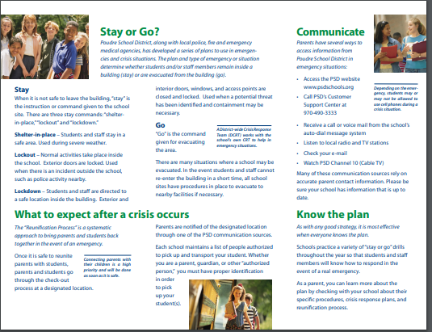

Field Trips
Permission for field trips will be obtained from parents in advance. Staff will supervise all children during excursions, ensuring that children are safe and accounted for. Parents are invited to join the class for field trips. If a child arrives late and the class has gone on a field trip, the teacher will leave instructions with the school site to provide the child with their daily instruction.
Remember, before going on a field trip to fill out the Volunteer agreement form. You can find the form at https://www.psdschools.org/community/volunteers.

Many Ways to Learn
During times of pandemic or other crisis, it may be essential for buildings to close. COVID 19 challenged school districts across America to think about service delivery for students in new and different ways, and we learned that in-person learning is not always possible. PSD Early Childhood is prepared to respond to a variety of scenarios for learning that will provide continued access to educational opportunities, whether in person, or remote.
PSD ECE will align as closely as possible to the school district for phases of instruction. We will also comply with state and local Public Health and Environment regulations for student and staff safety. The school district will have up-to-date information about closures or modifications to schedules, transportation and more at www.psdschools.org
It is an expectation from our funders that students continue to have access to services and education, even during public health crisis. You can expect to hear from your child’s teacher, your family mentor or other EC personnel if in-person learning is shifting. PSD Early Childhood no longer offers a remote-only virtual experience.
Possible Phases of Instruction for the school year:
Phase One:  Remote only | All students in all PSD classrooms access instruction remotely only. By contacting their child’s teacher, families without a device or access to the internet will receive program support to learn remotely.
Phase Two:  Mostly Remote  In person for select groups | Most students will learn remotely, with select in-person small groups attending some days and learning remotely on the other days of the week.
Phase Three:  Hybrid Remote and in person combination for all children | All students will access learning part in person, and part remotely. 50 % of class will attend half of each week.  Students will be grouped in Group A or Group B. Group A will attend Monday and Wednesday, and Group B will attend Tuesday and Thursday. Other days of the week will be remote instruction.
Phases Four:  In Person Instruction | All students attend 100% of the time in person.

Parent and Staff Conferences
Parent and staff conferences happen throughout the year to discuss child’s progress in both academics and social/behavior development. Parents and staff may request a conference at any time.

Guidance and Discipline
PSD Early Childhood Education uses guidance to help children replace undesired behaviors with desirable behaviors. The staff does not allow children to hurt themselves or others, use unacceptable language, or misuse materials. Staff members will not speak or act in any way that could degrade, shame or hurt a child. If a problem occurs, the teacher will help the child understand why the behavior is not working and teach strategies that work. If a child’s behavior continues and is an obstacle to the child’s development and/or interferes with learning and development of other children, the classroom teacher may contact the school psychologist for consultation and assistance or begin the District Multi-Tiered System of Support (MTSS) problem-solving process. MTSS explicitly involves parents at every step so that school observations and insight into the child’s life at home are blended. MTSS problem-solving includes social, academic, and behavioral interventions that promote the child’s success. Except for cases where the ongoing safety of the child and/or others is at risk, children will not be expelled, suspended, or excluded from the program.

Positive Behavior Support
Positive behavior techniques used by staff and parents increase the pro-social skills associated with successful academic performance and reduce challenging behaviors. To support positive behavior, talk to your teacher or mentor who can provide information on effective techniques and parenting classes to support your family.
Help your children remember these three simple program-wide rules:
- We keep ourselves safe.
- We keep each other safe.
- We keep our things safe.

Special Education (Integrated Services)
Special education services are available for children with special needs in Early Childhood Education. Please contact the Child Find Specialist at 970-490-3040 for additional information on special education programs. In addition, if your child is entering our program and has an IEP, you can contact our Disabilities Specialist at shahn@psdschools.org

Notice of Non-Discrimination
PSD ECE does not unlawfully discriminate based on race, color, national origin, sex, sexual orientation, age, marital status, or disability in admission or access to, or treatment or employment in, its educational programs or activities. Inquiries concerning Title VI, Title IX, Section 504, and ADA may be referred to the Office of Civil Rights, US Department of Education, 1244 N Speer Blvd, Suite 310, Denver, CO, 80204, 303-844-5695. Additionally, PSD is ready to assist you if you are concerned you or your child have been discriminated against.
For Student Discrimination: Contact your school’s principal. If you feel it was your school’s principal who discriminated against a student, contact Ruben Chacon, Director of Student Services, at 970-490-3033 or rchacon@psdschools.org
For Staff Discrimination: Contact PSD Human Resources, Executive Director of Human Resources at 970-490-3620.

Problem-Solving
PSD ECE is committed to working with you as a team. Parents are the child’s first and most enduring educator. We understand that conflict may occur and you may need support with problem solving. The program always recommends speaking directly with the person first, then to a supervisor if you need more support. For example, if the problem occurs in the classroom, you will want to speak with the teaching team first, and then to the principal if your concerns are not resolved. If you have concerns and need further assistance, please contact the Director or Assistant Director at 970-490-3204.

Procedures for Filing a Complaint
If there is a complaint regarding the PSD Early Childhood Education Program, all attempts will be made to reconcile the situation with the persons involved. If the complaint is not reconciled at the time, the Director and Policy Council will act as a grievance committee to reconcile the complaint.

Suspension and Expulsion
Except for cases where the ongoing safety of the child and/or others is at risk, children will not be expelled, suspended, or excluded from Early Childhood Education. Prior to reaching a decision to separate a child from the program temporarily or for the remainder of the school year, staff will use a variety of resources and techniques, including positive adult and child interactions, parent conferences, consultation with mental health specialist, support from a building based student success team (MTSS) and consultation with Early Learning Support Coordinator and/or Program director. All the steps in the process will be documented with parent involvement throughout.

Reporting Child Abuse
The law requires that every Early Childhood Education staff member reports any suspected condition of student neglect or abuse to the Department of Health and Human Services. Anyone who suspects child abuse should call Larimer County Department of Health and Human Services at 970-498-6990.
Reporting Preschool Licensing Violations
If licensing violations are suspected, complaints should be made to: Colorado Department of Human Services Offices of Early Childhood, 1575 Sherman Street, Denver, CO, 80202

Fees
PSD ECE does not charge fees for Early Head Start, Head Start, Colorado Preschool program or Integrated Services (Special Education) funded programs. At times, parents may have the option to provide money for special programs such as field trips; but at no time will this be required for a child to participate in regular classroom activities.
PSD ECE does charge for tuition-based preschool. Annual fees are: $3825 dollars, or $425 dollars per month for the 3.5 hour class. Fees for the 2.75 hour class are $3,528, or $392 per month. There is a one-time non-refundable enrollment fee that is due within 10 days of placement slot offering. In the event of pandemic or health crisis, and the program needs to shift from in-person to remote learning, you will still be able to access school via remote means and your tuition agreement will not change. Payment for tuition is made through School pay, either in a one-time lump sum, or monthly automated payments. Failure to pay tuition fees could result in offering your tuition slot to someone on the waitlist and a drop from the program.
This year, PSD has qualified for a grant that allows all students to eat for free in our program. However, we still encourage you to apply for Free/reduced lunch if your family qualifies. PSD Early Childhood Education ordinarily charges for meals if your family does not qualify for free or reduced meals. PSD’s Child Nutrition program will mail each family a flyer describing how to apply for Free/Reduced meals in late July or early August, which is when the portal opens for the upcoming school year. For more information, you can visit their website at https://www.psdschools.org/programs-services/school-meals/free-and-reduced-meals.
The program encourages parents to eat lunch with their children; however, there is a parent (adult rate) lunch fee.
The application process will ensure that if you are eligible for free or reduced lunch, you may qualify for other district services and community discounts. Additionally, families who qualify for Free and Reduced Meal benefits, are eligible for school fee/charge waivers. See the PSD student fees and charges web page for instructions on how to complete the Permission to Share Information for Fee/Charge Waivers form for Fee/Charge waivers form.

School Meals and Snacks
The PSD Child Nutrition department ensures that our children have healthy meals to help them learn. In classroom sessions that are 3.5 hours or longer, we provide a nutritious lunch and breakfast. Children in our all-day classrooms receive breakfast and lunch. Your child’s classroom will send home monthly food menus.
The price of breakfast and lunch will be determined based on free and reduced lunch status. If a family does not qualify for free lunch, there will be a daily charge for food. You can securely pay for meals using “School Pay” on the child nutrition website after the program grant is over.
Please check the PSD Child Nutrition website for menus and pricing. https://www.psdschools.org/programs-services/school-meals/
Need help paying for breakfast, lunch, and snack? Visit www.psdschools.org/programs-services/school-meals/free-and-reduced-meals and apply for Free & Reduced meal benefits. Even if you applied in previous years, your family must apply each year before September 30 to be eligible for assistance in the coming school year.
No family will be required to purchase school meals. Families also have the option to bring food from home. However, parents will need to provide healthy meals and snacks, as meals are a daily part of the early childhood learning environment.
At no time will a child be forced to eat. Children will be encouraged to taste food and determine if they like the food. Food is never used as a reward or punishment. You must mark your child or families food allergies, sensitivities and special diets on both the PSD Early Childhood application and the Health conditions form when registering for the program.
The school nurse for your child’s classroom will contact you regarding your child’s special dietary needs so that a plan can be made to keep him/her safe in school. Please keep in close contact with your child’s teacher regarding any special dietary needs letting them know if there are concerns about what is being served at school or if changes have occurred in your child’s diets.

Medication
In accordance with 12-38-132 C.R.S of the Nurse Practice Act, PSD Early Childhood Education staff is delegated by a registered nurse and properly trained to administer medication. Medication must be in the original container and have its original label. Written permission from a doctor to administer the medication is required as well as written permission from the parent/guardian. Parents must carry the medication to the classroom. Medication cannot be sent in the child’s backpack. A PSD medication authorization form MUST be completed before any medication can be administered to your child during school. All medication is always securely stored and inaccessible to children.

Pick Up Policy
Any person picking up your child must be authorized to pick up. To add or change anyone on the authorized list, please fill out a data change form (https://www.psdschools.org/sites/default/files/PSD/early_childhood/Applications/Form%20H%20Data%20Change%20Form_FILLABLE-1.pdf ) and return to Fullana or psdece@psdschools.org. Anyone picking up a child will be required to show a photo identification and staff members will check the authorized persons list before releasing the child.
Pick up and drop off routines may be adjusted slightly to meet public health regulations during times of pandemic/public health emergency.
If a person dropping off or picking up a child is suspected of being incapacitated in any way to care for the child, including being under the influence of drugs or alcohol, the staff member will:
- Inform school administration and ask for their support.
- Determine if the person picking up is a authorized. If not a parent, staff will call to inform the parent and to request they or another authorized person come immediately to pick up the child.
- If it is a parent, staff will inform them that they must contact a relative or a friend to accompany them.
- If the incapacitated adult leaves with the child, staff will inform the person that they will make a suspected impaired driver call to 911 as well as call DHS.

Release Authorization
Children must be dropped off and picked up by an adult 16 years old or older to be properly signed in and out per licensing regulations. Children will ONLY be released to authorized adults at least 16 years of age listed on the Emergency & Release to list. Authorized adults must provide a photo ID of the authorized adult. Staff are required to verify photo ID.
Please call the enrollment or front office teams to update Emergency and Release To lists at 970-490-3204 or email psdece@psdschools.org.
The office staff must have a copy of applicable restraining orders on file in order to enforce them.
If an authorized adult does not arrive to pick up the child or does not provide a photo ID, a staff member will stay with the child until an authorized adult, with ID arrives. If we are unable to reach any emergency contacts to come pick up the child within 30 minutes of dismissal, we will call law enforcement and the Department of Health and Human services, Child Protection.

School Cancelation Policy
Sometimes school is cancelled or delayed due to adverse weather conditions. If school is cancelled or delayed, you will get a phone call from the District letting you know of the closure or delay. You can also check the school website for more information at www.psdschools.org. If schools are delayed by 2 hours, called a late start, morning preschool classes are cancelled but afternoon classes will meet as usual, at the normal time. If schools are cancelled for the day, there will not be preschool classes. If you have a meeting scheduled with your family mentor, and school is cancelled, your meeting with your mentor will be cancelled as well. If you have a morning meeting with your Mentor and school is under a delayed start, your morning meeting will be cancelled. If you have an afternoon meeting your mentor, and schools are operating under a delayed start, your afternoon meeting will happen as scheduled.
It is very important that you keep your family information current including email and phone numbers so that the district can update you with information. If your information changes, please let the program know as soon as possible at 970-490-3204 or psdece@psdschools.org

Personal Belongings
Item brought from home, including money, toys, and food may cause problems on the bus and in the classroom. Children should only bring items from home that teachers request be brought.

Visitors
Visitors are required to sign in and state the purpose of their visit at the time of arrival at the school. All school visitors are required to wear a badge while in the school. Visitors are welcome to visit at any time and must avoid disrupting the program. If any visitor becomes disruptive for the students and/or the staff, the visitor will be asked to leave. In times of health crisis, the district may limit the visitors allowed in a school or classroom. Please contact your child’s teachers to learn about current health restrictions that may be in place.

Volunteering
Ask your child’s teacher or family mentor how you can become involved by volunteering. Some of the things they may need help with include preparing supplies for projects, attending a field trip as a chaperone, reading to small groups of children, or creating a classroom bulletin board. Any help you can give is always appreciated. Volunteers must register and pass background screening through the Poudre School District to work with children. Go to https://www.psdschools.org/community/volunteers to register as a PSD parent or community volunteer.

Smoking Policy
To promote the general health, welfare, and wellbeing of students and staff, smoking, chewing, or any other use of tobacco products by staff, volunteers, and members of the public is banned from school property. Anyone in violation of this policy will be asked by school staff members to leave school property.

School Hours
Center hours vary by school location. Holidays and school out days are listed in the calendar included in this handbook.

TV And Videos
TV and video are not routinely watched in the classroom. Specific television shows and videos may be shown on rare occasions in the classroom, as part of the weekly planned activities. Parents will be notified in advance in the classroom newsletters or by email. Parents are responsible to choose and limit the TV their child watches at home. The American Academy of Pediatrics recommends no TV at all for children under the age of two.

TV / Media Opt-Out
Occasionally, we will take photos of classroom activities to share on our website, in promotional materials, and on our social media. If you do not wish your child to be photographed, please fill out the media opt-out form included in your child’s enrollment or re-enrollment packets. You may also request this form by emailing psdece@psdschools.org or calling 970-490-3204.

Weather Conditions
Children in PSD Early Childhood Education Program will go outside as part of the daily curriculum. The principal and/or teachers at each school will determine if children need to be inside because of extreme weather conditions, including but not limited to high or low temperatures, wind chill, moisture, and wind. It is Early Childhood Education’s policy that children may not play outside if the temperature is 30 degrees or lower.

