Frequently Asked Questions
Q: What if I didn't complete this process by May 10, 2020?
A: Any carryover credits from your last lane change and PSD lane change-approved professional development taken before December 31, 2019, and not counted by May 10, 2020, will not be applied to future lane changes. University or other external credits you weren’t able to add can be added later.

Q: How can I see my credit bank?
A: We hope the credit banks will be available to you in the PSD PD system by July 1, 2020. Until then, go back into Employee Records and look at the documents in your FILES. If HR has processed it already, the forms you completed will be there.
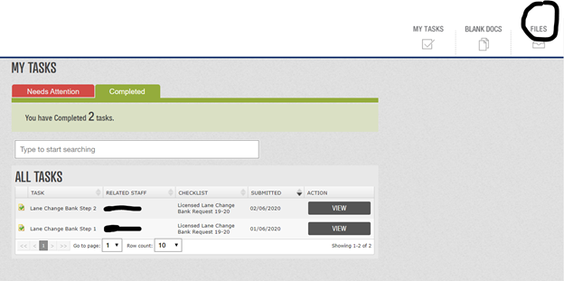

Q: How can I apply for my CDE license renewal if the credit banks aren’t set up yet?
A: Your PSD PD transcript is still available in the PD system, just as always.

Q: I completed enough credits for a lane change now; how do I apply between NOW and August?
A: We will not accept lane changes for August until the new online lane change process is available, hopefully on or around July 1, 2020. We’ll send out information about the new process ASAP. Remember that classes completed after December are not effective until August, so you will not lose out on any pay by waiting to apply for a lane change.

Q: I’ve completed PSD professional development classes since 12/31/2019; how can I get them into my bank?
A: We will begin adding new credits to your credit bank for courses taken after December 31, 2019, as soon as possible after the school year ends but no later than August 2020. After you have completed a PSD lane-change approved course, the Professional Development department has reconciled it, and you have completed the survey, it will come directly to us for approval and entry into your credit bank.

Q: I’ve completed university classes since 12/31/2019; how can I get them into my bank?
A: the credit banks will take some time to set up; after the process is complete, we will send out information about how to will begin adding new credits to your credit bank for courses taken after December 31, 2019, as soon as possible after the school year ends but no later than August, 2020. After you have completed a PSD lane-change approved course, the Professional Development department has reconciled it, and you have completed the survey, it will come directly to us for approval and entry into your credit bank.

Frequently Asked Questions
Q: What’s this all about, and why did I have to establish a credit bank?
A: We’re automating the lane change and professional development tracking process. In preparation, PD credits had to have been put in your credit bank.

Q: What’s in it for me?
A: You’ll be able to keep track of all professional development credits- PSD PD, university, and other outside credits- in one location, your CREDIT BANK. You’ll also know instantly when you’re ready for a lane change and be able to apply for a lane change quickly and easily.

Q: What’s in this credit bank?
A: To begin, all carryover hours from your last lane change and any lane change-approved credits you’ve earned through December 31, 2019, will be in your credit bank. After August 1, 2020, ALL professional development credits and transcripts you upload will be in this bank.

Q: Why is my credit bank at 0?
A: There are several possible reasons your bank was set at 0, including:
- You’re on Lane J (MA+52) or K (PhD), so you don’t need a credit bank.
- You had no carryover credits and no new PD completed since your last lane change and before 12/31/19.
- You did not complete the credit bank application process by May 10, 2020.

Q: What counts for lane change credit?
A: Graduate level university classes and applicable PSD professional development credits purchased for lane change credit will count towards your lane change. These courses will appear on your transcript under the “Lane Change/License” tab.

